**Komunikacijska elektronika**

**Poročilo o laboratorijskih vajah: Digitalni osciloskop**

Ime in Priimek:

**Vaja 1:** Digitalni osciloskop LeCroy

Vezava:



* Meritev parametrov

Parametri:

* + Frekvenca 10kHz,
  + Amplituda 10V,
  + trikoten signal

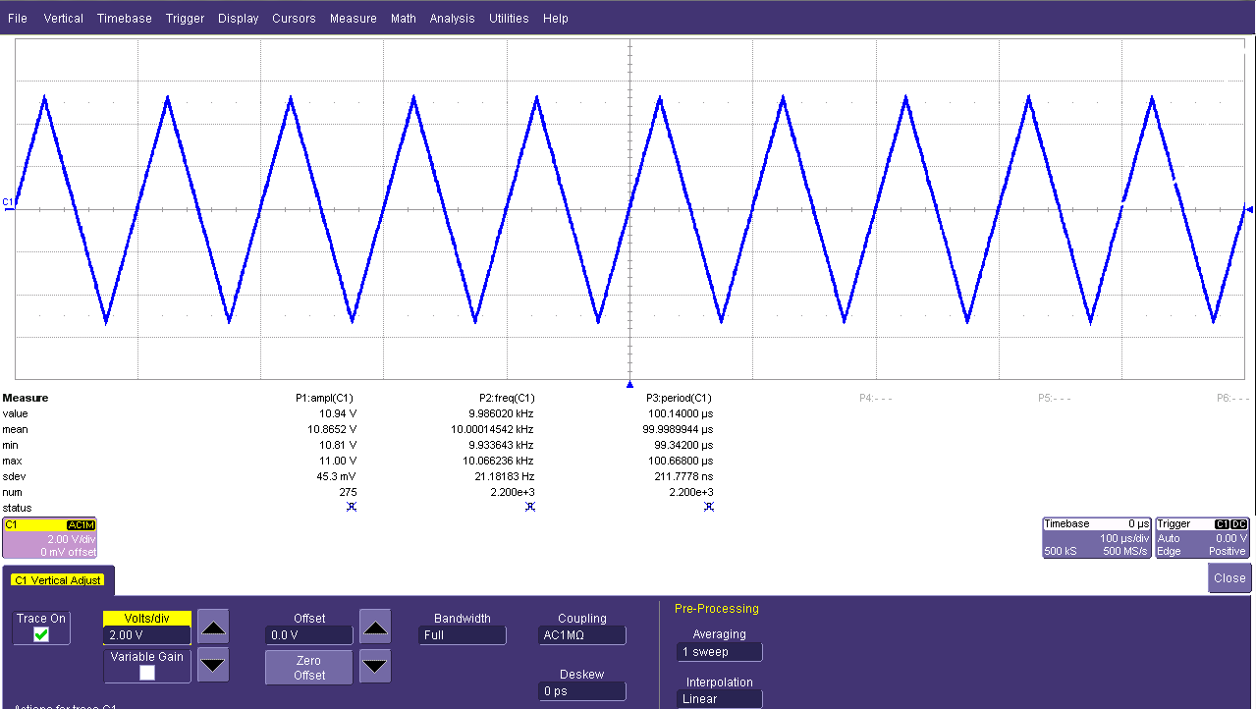

* Statistične meritve (šumni generator)

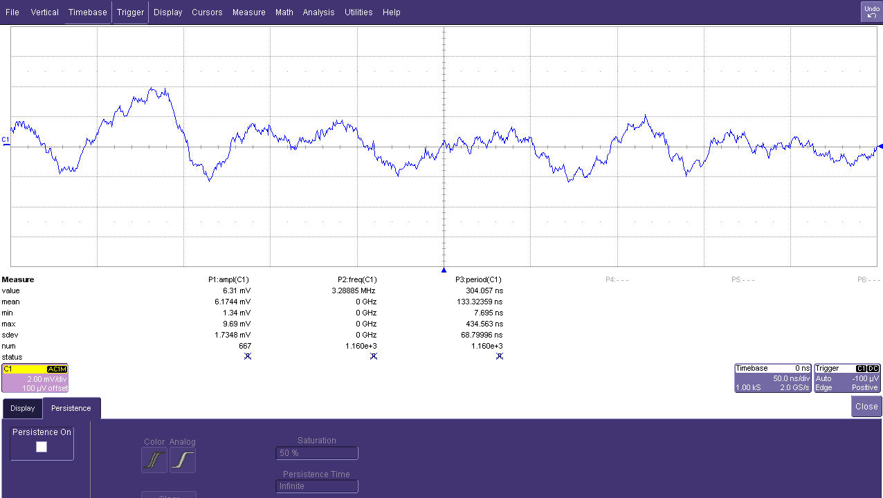

* Merjenje sipanja (jitter) pravokotnega signala z uporabo spremenljive persistence

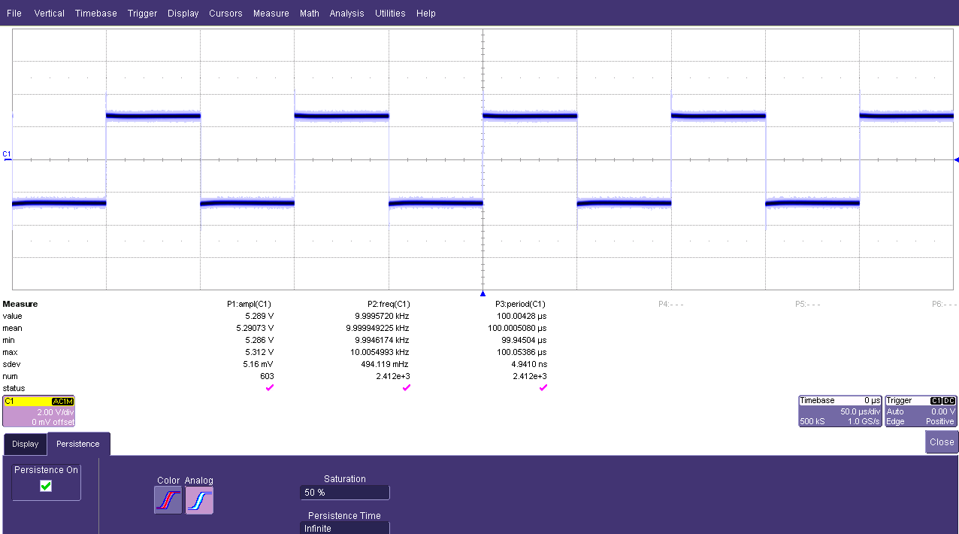

**Vaja 3:** Meritve linearnega sistema z osciloskopom

Blok shema meritve:



Rezultati:

|  |  |  |  |  |  |  |  |  |  |  |  |  |  |  |  |  |  |  |  |  |  |  |  |  |  |  |  |  |  |  |  |  |  |  |  |  |  |  |  |  |  |  |  |
| --- | --- | --- | --- | --- | --- | --- | --- | --- | --- | --- | --- | --- | --- | --- | --- | --- | --- | --- | --- | --- | --- | --- | --- | --- | --- | --- | --- | --- | --- | --- | --- | --- | --- | --- | --- | --- | --- | --- | --- | --- | --- | --- | --- |
| * + Mejna frekvenca fp= 10kHz   + Ojačanje četveropola:  |  |  |  | | --- | --- | --- | |  | Frekvenca (f) | Ojačanje (a) | | 1 | 100 Hz | 13,74 dB | | 2 | 500 Hz | 13,67 dB | | 3 | 1000 Hz | 13,64 dB | | 4 | 4000 Hz | 13,61 dB | | 5 | 10000 Hz | 10,88 dB | | * + Fazni zasuk med vhodom in izhodom:  |  |  |  |  | | --- | --- | --- | --- | |  | Frekvenca | Zakasnitev | Faza | | 1 | 100 Hz | -4,7 ms | 178,7 ᵒ | | 2 | 500 Hz | -2,4 ms | 175,3 ᵒ | | 3 | 1000 Hz | -476,3 us | 172,8 ᵒ | | 4 | 4000 Hz | -105,4 us | 159,6 ᵒ | | 5 | 10000 Hz | -34,4 us | 128,7 ᵒ | |

Bodejev diagram: