PREVERJANJE ZNANJA PRI VAJAH IZ BIOINFORMATIKE

NAVODILA ZA REŠEVANJE:
Čas reševanja je 45 min (+ 5 min)

1. Določila si naslednje nukleotidno zaporedje:

TGTTTCCGCTGCATCCAGACTTCCTCAGGCGGTGGCTGGAGGCTGCGCATCTGGGGCTTTAAACATACAA
AGGGATTGCCAGGACCTGCGGCGGCGGCGGCGGCGGCGGGGGCTGGGGCGCGGGGGCCGGACCATGAGCC
GCTGAGCCGGGCAAACCCCAGGCCACCGAGCCAGCGGACCCTCGGAGCGCAGCCCTGCGCCGCGGACCAG
GCTCCAACCAGGCGGCGAGGCGGCCACACGCACCGAGCCAGCGACCCCCGGGCGACGCGCGGGGCCAGGG
AGCGCTACGATGGAGGCGCTAATGGCCCGGGGCGCGCTCACGGGTCCCCTGAGGGCGCTCTGTCTCCTGG
GCTGCCTGCTGAGCCACGCCGCCGCCGCGCCGTCGCCCATCATCAAGTTCCCCGGCGATGTCGCCCCCAA
AACGGACAAAGAGTTGGCAGTGCAATACCTGAACACCTTCTATGGCTGCCCCAAGGAGAGCTGCAACCTG
TTTGTGCTGAAGGACACACTAAAGAAGATGCAGAAGTTCTTTGGACTGCCCCAGACAGGTGATCTTGACC
AGAATACCATCGAGACCATGCGGAAGCCACGCTGCGGCAACCCAGATGTGGCCAACTACAACTTCTTCCC
TCGCAAGCCCAAGTGGGACAAGAACCAGATCACATACAGGATCATTGGCTACACACCTGATCTGGACCCA
GAGACAGTGGATGATGCCTTTGCTCGTGCCTTCCAAGTCTGGAGCGATGTGACCCCACTGCGGTTTTCTC
GAATCCATGATGGAGAGGCAGACATCATGATCAACTTTGGCCGCTGGGAGCATGGCGATGGATACCCCTT
TGACGGTAAGGACGGACTCCTGGCTCATGCCTTCGCCCCAGGCACTGGTGTTGGGGGAGACTCCCATTTT
GATGACGATGAGCTATGGACCTTGGGAGAAGGCCAAGTGGTCCGTGTGAAGTATGGCAACGCCGATGGGG
AGTACTGCAAGTTCCCCTTCTTGTTCAATGGCAAGGAGTACAACAGCTGCACTGATACTGGCCGCAGCGA
TGGCTTCCTCTGGTGCTCCACCACCTACAACTTTGAGAAGGATGGCAAGTACGGCTTCTGTCCCCATGAA
GCCCTGTTCACCATGGGCGGCAACGCTGAAGGACAGCCCTGCAAGTTTCCATTCCGCTTCCAGGGCACAT
CCTATGACAGCTGCACCACTGAGGGCCGCACGGATGGCTACCGCTGGTGCGGCACCACTGAGGACTACGA
CCGCGACAAGAAGTATGGCTTCTGCCCTGAGACCGCCATGTCCACTGTTGGTGGGAACTCAGAAGGTGCC
CCCTGTGTCTTCCCCTTCACTTTCCTGGGCAACAAATATGAGAGCTGCACCAGCGCCGGCCGCAGTGACG
GAAAGATGTGGTGTGCGACCACAGCCAACTACGATGACGACCGCAAGTGGGGCTTCTGCCCTGACCAAGG
GTACAGCCTGTTCCTCGTGGCAGCCCACGAGTTTGGCCACGCCATGGGGCTGGAGCACTCCCAAGACCCT
GGGGCCCTGATGGCACCCATTTACACCTACACCAAGAACTTCCGTCTGTCCCAGGATGACATCAAGGGCA
TTCAGGAGCTCTATGGGGCCTCTCCTGACATTGACCTTGGCACCGGCCCCACCCCCACACTGGGCCCTGT
CACTCCTGAGATCTGCAAACAGGACATTGTATTTGATGGCATCGCTCAGATCCGTGGTGAGATCTTCTTC
TTCAAGGACCGGTTCATTTGGCGGACTGTGACGCCACGTGACAAGCCCATGGGGCCCCTGCTGGTGGCCA
CATTCTGGCCTGAGCTCCCGGAAAAGATTGATGCGGTATACGAGGCCCCACAGGAGGAGAAGGCTGTGTT
CTTTGCAGGGAATGAATACTGGATCTACTCAGCCAGCACCCTGGAGCGAGGGTACCCCAAGCCACTGACC
AGCCTGGGACTGCCCCCTGATGTCCAGCGAGTGGATGCCGCCTTTAACTGGAGCAAAAACAAGAAGACAT
ACATCTTTGCTGGAGACAAATTCTGGAGATACAATGAGGTGAAGAAGAAAATGGATCCTGGCTTTCCCAA
GCTCATCGCAGATGCCTGGAATGCCATCCCCGATAACCTGGATGCCGTCGTGGACCTGCAGGGCGGCGGT
CACAGCTACTTCTTCAAGGGTGCCTATTACCTGAAGCTGGAGAACCAAAGTCTGAAGAGCGTGAAGTTTG
GAAGCATCAAATCCGACTGGCTAGGCTGCTGAGCTGGCCCTGGCTCCCACAGGCCCTTCCTCTCCACTGC
CTTCGATACACCGGGCCTGGAGAACTAGAGAAGGACCCGGAGGGGCCTGGCAGCCGTGCCTTCAGCTCTA
CAGCTAATCAGCATTCTCACTCCTACCTGGTAATTTAAGATTCCAGAGAGTGGCTCCTCCCGGTGCCCAA
GAATAGATGCTGACTGTACTCCTCCCAGGCGCCCCTTCCCCCTCCAATCCCACCAACCCTCAGAGCCACC
CCTAAAGAGATCCTTTGATATTTTCAACGCAGCCCTGCTTTGGGCTGCCCTGGTGCTGCCACACTTCAGG
CTCTTCTCCTTTCACAACCTTCTGTGGCTCACAGAACCCTTGGAGCCAATGGAGACTGTCTCAAGAGGGC
ACTGGTGGCCCGACAGCCTGGCACAGGGCAGTGGGACAGGGCATGGCCAGGTGGCCACTCCAGACCCCTG
GCTTTTCACTGCTGGCTGCCTTAGAACCTTTCTTACATTAGCAGTTTGCTTTGTATGCACTTTGTTTTTT
TCTTTGGGTCTTGTTTTTTTTTTCCACTTAGAAATTGCATTTCCTGACAGAAGGACTCAGGTTGTCTGAA
GTCACTGCACAGTGCATCTCAGCCCACATAGTGATGGTTCCCCTGTTCACTCTACTTAGCATGTCCCTAC
CGAGTCTCTTCTCCACTGGATGGAGGAAAACCAAGCCGTGGCTTCCCGCTCAGCCCTCCCTGCCCCTCCC
TTCAACCATTCCCCATGGGAAATGTCAACAAGTATGAATAAAGACACCTACTGAGTGGC

a) Koliko odprtih bralnih okvirjev ima to nukleotidno zaporedje? Katero predstavlja kodirajočo regijo?

ORF: A section of a sequenced piece of DNA that begins with an initiation (methionine ATG) codon and ends with a nonsense codon. ORFs all have the potential to encode a protein or polypeptide, however many may not actually do so.

b) Kakšna je izolelektrična točka proteina, ki ga kodira zgornje nukleotidno zaporedje?

c) Poišči, kateremu človeškemu proteinu ustreza.

2. S pomočjo filogenetskega drevesa ugotovi, protein iz katerega organizma se najbolj razlikuje od vseh ostalih podobnih proteinov.

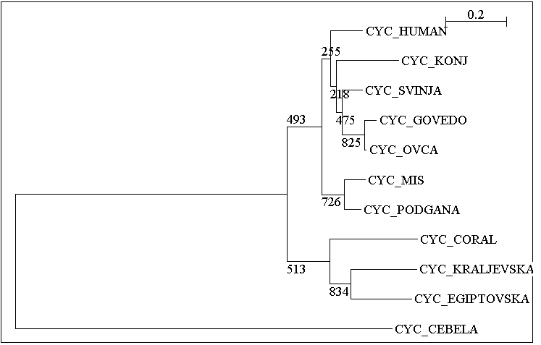

3. Za dano aminokislinsko zaporedje ugotovi, kakšen odstotek bazičnih in kislin aminokislin vsebuje?

Zaporedje je navedeno v dokumentu v Excelu.

4. Molekulo papaina (datoteka s koordinatami 9PAP na vašem direktoriju) predstavite v obliki ribbon, ki je obarvana glede na sekundarno strukturo. Na tej sliki prikažite stranske skupine aminokislinskih ostankov Cys25, His159 in Asn175. Izmerite in prikažite razdaljo med Cys25 in His159. Sliko shranite pod imenom naloga2.tga, najprej na trdi disk, nato pa jo skrčite na disketo.

5. a) Kaj predstavlja najdaljši odprti bralni okvir?

b) Za kateri protein (A ali B) je predstavljen?
A

B

