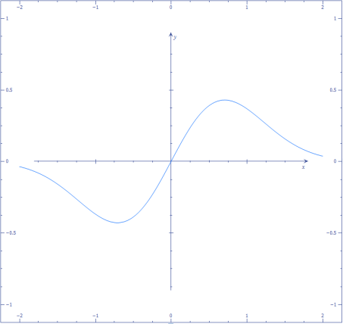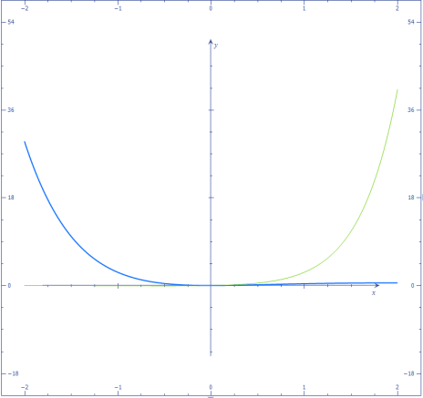

1: x*e^(-x^2)

2 : x^2e^(-x) ; gor : x*e^(2x-1)  
x*e^(-x) – prezrcaljena modra čez X-os  
gor tudi x^2*e^(x-1)

Slika - (x-2)/(x+1)

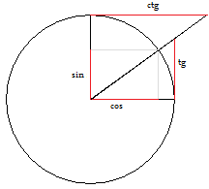

**Zaporedje člen: $$|1-an|<ε$$**  
  
an – formula zaporedja

**Tangenta na krivuljo v točki $(x_{0},f\left(x_{0}\right))$: $$y-f\left(x_{0}\right)=f^{'}\left(x_{0}\right)(x-x_{0})$$**

**Iz polarne v normalno (kompleksna): $$a=r*\cos{φ} ; b=r*\sin{φ}$$**

Določen integral: $$\int_{a}^{b}{f\left(x\right)dx=F\left(x\right)\begin{matrix}b \\ | \\ a\end{matrix}=F\left(b\right)-F\left(a\right)} \\ \int_{a}^{b}{f\left(x\right)dx}=-\int_{b}^{a}{f\left(x\right)dx} \\ \int_{a}^{b}{[f\left(x\right)±g(x)]}=\int_{a}^{b}{f\left(x\right)dx±\int_{a}^{b}{g\left(x\right)dx}}$$

Ostalo: $${\left(a±b\right)}^{2}=a^{2}±2ab+b^{2} \\ {\left(a±b\right)}^{3}=a^{3}±3a^{2}b+3ab^{2}±b^{3} \\ a^{-n}=\frac{1}{a^{n}} ; \sqrt[n]{a^{m}}=a^{\frac{m}{n}} \\ log{ a}^{n}=n*\log{a} ;\log{\sqrt{a}=\frac{1}{2}\log{a}} \\ x_{1,2}=\frac{-b±\sqrt{b^{2}-4ac}}{2a}$$

Pravila integriranja: $$\int{f\left(x\right)dx=F\left(x\right)+C} \\ \int{C*f\left(x\right)dx=C\int{f\left(x\right)dx}} \\ \int{\left[f\left(x\right)±g(x)\right]dx}=\int{f\left(x\right)dx}±\int{g\left(x\right)dx}$$

**Osnovni integrali:**

|  |  |
| --- | --- |
|  |  |
|  |  |
|  |  |
|  |  |
|  |  |

Če $f^{'}\left(x\right)=0:$ minimum: $f^{''}\left(x\right)>0$ maksimum: $f^{''}\left(x\right)<0$

**Odvod: $f^{'}\left(x\right)=\lim_{∆x→0}\frac{f\left(f+∆x\right)-f(x)}{∆x}=\lim_{∆x→0}\frac{∆y}{∆x}=\frac{dy}{dx}=\lim_{∆x→0}tgβ=tgα$**

|  |  |
| --- | --- |
| Funkcija | Odvod |
| $$y=C ;C-konstanta$$ | $$y^{'}=0$$ |
| $$y=f\left(x\right)±g\left(x\right)±h(x)$$ | $$y^{'}=f^{'}\left(x\right)±g^{'}\left(x\right)±h^{'}(x)$$ |
| $$y=C*f(x)$$ | $$y^{'}=c*f^{'}(x)$$ |
| $$y=f\left(x\right)*g(x)$$ | $$y^{'}=f^{'}\left(x\right)*g\left(x\right)+f\left(x\right)*g^{'}(x)$$ |
| $$y=\frac{f(x)}{g(x)}$$ | $$y^{'}=\frac{f^{'}\left(x\right)*g\left(x\right)-f\left(x\right)*g^{'}(x)}{{(g\left(x\right))}^{2}}$$ |
| $$y=f[g(x)]$$ | $$y^{'}=f^{'}\left[g\left(x\right)\right]*g^{'}(x)$$ |

**Osnovni odvodi:**

|  |  |  |  |  |
| --- | --- | --- | --- | --- |
| **func** | **odvod** |  | **func** | **Odvod** |
| C (konst) | 0 |  | $$x^{n}$$ | $$n*x^{n-1}$$ |
| x | 1 |  | $$a*x^{n}$$ | $$an*x^{n-1}$$ |
| Cx | C |  | $$\sqrt{x}$$ | $$\frac{1}{2\sqrt{x}}$$ |
| $$\frac{1}{x}$$ | $$-\frac{1}{x^{2}}$$ |  | $$\sqrt[n]{x}$$ | $$\frac{1}{n\sqrt[n]{x^{n-1}}}$$ |
| $$\frac{1}{x^{n}}$$ | $$-\frac{n}{x^{n+1}}$$ |  | $$lnx$$ | $$\frac{1}{x}$$ |
| $$a^{x}$$ | $$a^{x}*lna$$ |  | $$\log_{a}x$$ | $$\frac{1}{x*lna}$$ |
| $$e^{x}$$ | $$e^{x}$$ |  | $$arc\sin{x}$$ | $$\frac{1}{\sqrt{1-x^{2}}}$$ |
| $$sinx$$ | $$\cos{x}$$ |  | $$arc\cos{x}$$ | $$-\frac{1}{\sqrt{1-x^{2}}}$$ |
| $$cosx$$ | $$-sinx$$ |  | $$arc tg x$$ | $$\frac{1}{1-x^{2}}$$ |
| $$tgx$$ | $$\frac{1}{\cos^{2}x}$$ |  | $$arc ctg x$$ | - $\frac{1}{1-x^{2}}$ |
| $$ctgx$$ | $$-\frac{1}{\sin^{2}x}$$ |  |  |  |

**Limite: $$\lim_{x→x0}\left[f\left(x\right)±/*g(X)\right]=\lim_{x→x0}f\left(x\right)±/*\lim_{x→x0}g(x) \\ \lim_{x→x0}\left[c*f\left(x\right)\right]=c*\lim_{x→x0}f\left(x\right) \\ \lim_{x→x0}\left[\log{f\left(x\right)}\right]=\log\left[\lim_{x→x0}f\left(x\right)\right] ; \lim_{x→x0}\sqrt{f\left(x\right)}=\sqrt{\lim_{x→x0}f\left(x\right)} \\ \lim_{x→x0}{\left[f\left(x\right)\right]}^{n}={\left[\lim_{x→x0}f\left(x\right)\right]}^{n} ; \lim_{x→x0}g\left(f\left(x\right)\right)=g\left(\lim_{x→x0}f\left(x\right)\right) \\ \lim_{x→x0}c^{f(x)}=c^{\lim_{x→x0}f(x)}$$**

$$\sin^{2}α+\cos^{2}α=1 ;tgα=\frac{sinα}{cosα}$$

**Kompleksna števila $$\left(a+bI\right)∓\left(c+dI\right)=\left(a∓c\right)+\left(b∓d\right)I \\ \left(a+bI\right)*\left(c+dI\right)=\left(ac-bd\right)+\left(ad+bc\right)I \\ I^{1}=I ; I^{2}=-1;I^{3}=-I;I^{4}=1 \\ z=a+bI ;w=c+dI \\ \overline{z}=a-bI-konjugirano število \\ \left|z\right|=\left|\overline{z}\right|=\sqrt{a^{2}+b^{2}}- absolutna vrednost \\ \frac{z}{w}=\frac{z\overline{w}}{w\overline{w}}=\frac{z*\overline{w}}{c^{2}+d^{2}} \\ z^{\frac{x}{y}}=\frac{1}{y}{\left(a+bI\right)}^{x}$$**  
  
**Polarni zapis: $$z=r\left(cosφ+Isinφ\right)- trigeometrični zapis \\ z=r*e^{Iφ}- ekspotencjalni zapis \\ r=\left|z\right| \\ φ=\left\{\begin{aligned}arc\tan\left(\frac{b}{a}\right);a>0 \\ arc\tan\left(\frac{b}{a}\right)+π;a<0 ∧b≥0 \\ arc\tan\left(\frac{b}{a}\right)-π;a<0 ∧b<0 \\ +\frac{π}{2} ;a=0∧y>0 \\ +\frac{π}{2} ;a=0∧y<0\end{aligned}\right. \\ \left|z+w\right|≤\left|z\right|+\left|w\right| ; \left|z*w\right|=\left|z\right|*|w|$$**

|  |  |  |  |  |  |  |  |  |
| --- | --- | --- | --- | --- | --- | --- | --- | --- |
|  | **0** | **30** | **45** | **60** | **90** | **180** | **270** | **360** |
|  | **0π** | **π/6** | **π/4** | **π/3** | **π/2** | **π** | **3 π/2** | **2 π** |
| **Sin** | 0 | ½ | $$\sqrt{2}/2$$ | $$\sqrt{3}/2$$ | 1 | 0 | -1 | 0 |
| **Cos** | 1 | $$\sqrt{3}/2$$ | $$\sqrt{2}/2$$ | ½ | 0 | -1 | 0 | 1 |
| **Tg** | 0 | $$\sqrt{3}/3$$ | 1 | $$\sqrt{3}$$ | ∓∞ | 0 | ∓∞ | 0 |
| **ctg** | ∓∞ | $$\sqrt{3}$$ | 1 | $$\sqrt{3}/3$$ | 0 | ∓∞ | 0 | ∓∞ |