 | FS - Laboratorij za preizkušanje materialov
 | Gradiva - natezni preizkus
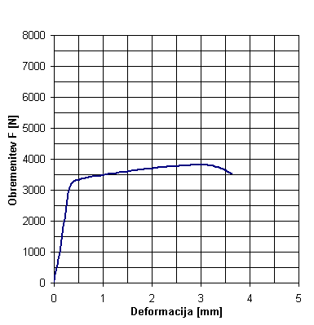 |  |  |  |  |  |  |  |  |  |  |  | 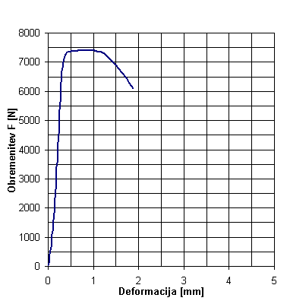
 | Datum: | 09. 04. 04 - 13:12 |  |  |  |  |  |  |  |  |  |  | Datum: | 09. 04. 04 - 13:17
 | Material: | AlCu6BiPb-sk1 |  |  |  |  |  |  |  |  |  |  | Material: | C15E4
 | do: | 4,0 | mm |  |  |  |  |  |  |  |  |  | do: | 4,0 | mm
 | lo: | 20,0 | mm |  |  |  |  |  |  |  |  |  | lo: | 20,0 | mm
 | Fm= | 3818 | N |  |  |  |  |  |  |  |  |  | Fm= | 7402 | N
 | Rm= | 304 | MPa |  |  |  |  |  |  |  |  |  | Rm= | 589 | MPa

