UNIVERSITY OF LJUBLJANA
FACULTY OF NATURAL SCIENCES AND ENGINEERING
DEARTMENT OF TEXTILES

History of knitting:
Hosiery
- Seminar paper -

Track of study:
Planning Textiles and Clothing, 2nd year

Mentors: Authors:
Doc. Dr. Alenka Pavko – Čuden G. N.
Lekt. Barbara Luštek Š. B.
V. M.

Ljubljana, December 2009

ABSTRACT

In our seminar paper we described first history of knitting. What is knitting, when and where they discovered the first examples of knitted products, socks. The origins of knitting are hard to trace therefore are several theories where was knitting started. The dilema is aslo in this if the earliest socks were worked in nalebinding or in true knitting. We wrote also about knitting guilds, which the craftsmans were united in. We also describe what was happening with knitting when America entered in world war two and about a decline of hosiery crafts after that. Furthermore we wrote about 21st century revival of knitting. Moreover we decribed what was happening with hosiery in Slovenia all of the guilds their crafts and all the way to mechanically knitting. We mentioned also the most specialised producer of hosiery in Slovenia, Polzela d.d., which is the biggest producer of hoisery in Europe. At the end we wrote about history of knitting machines intended for socks and who invented first knitting machine and others. There are many types of knitting machines from simple to very complex and electronic. As a interesting why they invent the machine is that the machine had done much work in twelve hours as it could make ten people at the same time manually. Therefore knitting machines almost replace hand knitting, which is present today as a hobby.

IZVLEČEK

V seminarski nalogi smo najprej opisali zgodovino pletenja. Kaj je pletenje, kje in kdaj so odkrili prve primere pletenih izdelkov, nogavice. Izvor pletilstva je težko določljiv, zato obstaja več različnih teorij o njegovem izvoru. Dilema pa je tudi v tem, ali so bile prve nogavice izdelane po skandinavski umetnosti z iglo, ki je podobna pletenju, ali s pravim pletenjem. Pisali smo tudi o pletilskih cehih, v katere so se združevali obrtniki. Prav tako smo opisovali tudi kaj se je dogajalo s pletenjem, ko je Amerika vstopila v drugo svetovno vojno in o tem kako je upadala nogavičarska obrt. V nadaljevanju smo pisali o preporodu pletenja v 21. stoletju. Raziskovali smo tudi kaj se je dogajalo v Sloveniji vse od cehov, njihove obrti in vse tja do strojnega pletenja. Omenjali smo tudi najbolj specializirano proizvajalko nogavic v Sloveniji, Polzelo d.d., ki je tudi največja proizvajalka nogavic v celotni Evropi. Na koncu smo pisali o zgodovini pletilnikov namenjenih nogavicam in o njihovih izumiteljih. Poznamo veliko vrst pletilnikov, vse od najenostavnejših, pa tja do zelo kompleksnih in elektronskih. Kot zanimivost zakaj so izumljali stroje je ta, da je stroj v dvanajstih urah naredil veliko več dela, kot pa bi to naredilo 10 delavcev v istem času ročno. Zato so pletilni stroji skoraj povsem zamenjali ročno pletenje, ki je v današnjih dneh le kot hobi.

TABLE OF CONTENTS
ABSTRACT 2
In our seminar paper we described first history of knitting. What is knitting, when and where they discovered the first examples of knitted products, socks. The origins of knitting are hard to trace therefore are several theories where was knitting started. The dilema is aslo in this if the earliest socks were worked in nalebinding or in true knitting. We wrote also about knitting guilds, which the craftsmans were united in. We also describe what was happening with knitting when America entered in world war two and about a decline of hosiery crafts after that. Furthermore we wrote about 21st century revival of knitting. Moreover we decribed what was happening with hosiery in Slovenia all of the guilds their crafts and all the way to mechanically knitting. We mentioned also the most specialised producer of hosiery in Slovenia, Polzela d.d., which is the biggest producer of hoisery in Europe. At the end we wrote about history of knitting machines intended for socks and who invented first knitting machine and others. There are many types of knitting machines from simple to very complex and electronic. As a interesting why they invent the machine is that the machine had done much work in twelve hours as it could make ten people at the same time manually. Therefore knitting machines almost replace hand knitting, which is present today as a hobby. 2
IZVLEČEK 3
TABLE OF CONTENTS 4
INTRODUCTION 5
History of knitting 6
Knitted socks 8
Knitting guilds 9
Knitting for Victory -- World War II 10
A Decline 11
Early 21st Century Revival 11
History of hosiery in Slovenija 12
15
First factories of knitwear and socks in Slovenia 15
History and present in Polzela d.d. 17
History of knitting machines (intended for sockings) 18
To the development of hand spinning machine at home 20
Knitting machines today 21
Shared history of knitting machine 22
CONCLUSION 24
SOURCES 25
1.)Pavko Čuden Alenka, 2000, Tekstilec let.43, št.7-8, str. 277-288 25
2.)Brackenbury Terry, 1992, Knitted Clothing Technology, str. 2-3 25
a)http://www.theknittree.com/knithistory.html, 10.12. 2009 25
b)http://www.knit-a-square.com/knitting-machines.html, 12.12.2009 26
c)http://en.wikipedia.org/wiki/Knitting_machine, 12.12.2009 26
d)http://sourcing.indiamart.com/apparel/apparel-industry/knitted-garments-information/history-of-knitting/, 12.12.2009 26

GALLERY INDEX

Slika 1: hand knitting 6
Slika 2: first knitted socks, Victoria and Albert Museum, London 9
Slika 3: fashionable knitted socks from France 9
Slika 4: reconstruction of former knitting craft 14
Slika 5: socks with studes 15
Slika 6: Kurnikova house 15
Slika 7: logotype of Polzela d.d. 17
Slika 8: William Lee, pioneer or the illustrated knitting frame 19
Slika 9: home knitting machine 20
Slika 10: modern industrial knitting machine in action 22

INTRODUCTION

For this seminar paper we chose a title History of knitting. In details we described history of hosiery in the world and in Slovenia from handknitting to knitting with Strickmaschines. This particular area seems to us very interesting, because we meet with socks, stockings, pantyhose etc every day in our life, but we know very little about their history, their development and machinery which makes them. By the time meaning of hoisery is changing. Today socks are consumers material, when they are toren, we throw them away, but in the past there was a place where they were repearing socks. Also today their function is not just protection and heating but also as fashion accesories, for medical purposes etc.

History of knitting
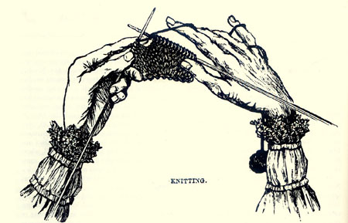

Slika 1: hand knitting

Knitting is "Combining a piece of thread with two needles into a piece of fabric."Its origins lie in the basic human need for clothing for protection against the elements. More recently, knitting has become less a necessary skill and more a hobby. Knitting has changed a lot through history. Even today, there are different methods and styles in different parts of the world. (l)

Knitting is something we are all familiar with, but surprisingly we know little about when and where the art of hand knitting started. This is because yarn fibers are biodegradable. One thing we do know is that the oldest form of knitting (crossed knitting) was practiced since before the birth of Christ. A pair of knitted socks discovered in Egyptian tombs from the 3rd to 6th centuries A.D. is the earliest archaeological evidence of knitted garments. The earliest knitting needle is a brass rod that dates back to the early Iron Age. Spinning wool started around 4000 B.C. near the Mediterranean Sea. The first wool factory in England was build by the Romans in 50 A.D. The kind of knitting that we are used to was not practiced till quite recently, however.
The oldest form of knitting is crossed knitting, also known as single-needle knitting and pseudo knitting. In crossed knitting, the stitches are rotated a half turn instead of aligning vertically. This knitting method was highly developed by the Nazca culture in Peru (100 B.C.-A.D. 700) in the fringes of their woven cloths. Frequent color changes in these fringes were used to create intricate human and animal figures.
The origins of knitting are hard to trace but there are several theories. Some people believe that knitting started in Persia, others that it started in Israel, Jordan and Syria. Still others believe that it started in the mountains of North Africa, or even Japan or China. Some people believe that knitting grew out of the knitting of fish-nets by men.
Some socks and other items made with the crossed-knitting technique have been found in Egyptian burials possibly dating as far back as the 4th or 5th century B.C. There have been knitted socks found in Egyptian tombs (3rd and 6th centuries A.D., knitted pieces found at the Dura-Europas site near the Euphrates River (about A.D. 200), and sandal socks apparently from Saudi Arabia (about A.D. 350). It is possible however that these earliest socks were worked in nalebinding; which is an ancient craft which often looks very similar to true knitting, and could be confused with true knitting by archaeologists with no training in the history of needlework. A pair of patterned cotton socks from Egypt, dating from A.D.1100 may be the earliest example of "true" knitting or that may be nalebinding too. Socks and stockings were the first items to be knitted because knitting was ideally suited for shaping a garment to fit the foot at a time when fabric and sewing woven cloth were less flexible.
It was not until the early 14th century that we have the first references to true knitting in Europe. At that time, the purl stitch was unknown, which meant that in order to produce plain knitting, people had to knit in the round and then cut it open if they needed to. The first reference to purl stitch was not until the mid 16th century, but the knowledge of how to do it may have preceded that a little.

Knitted socks
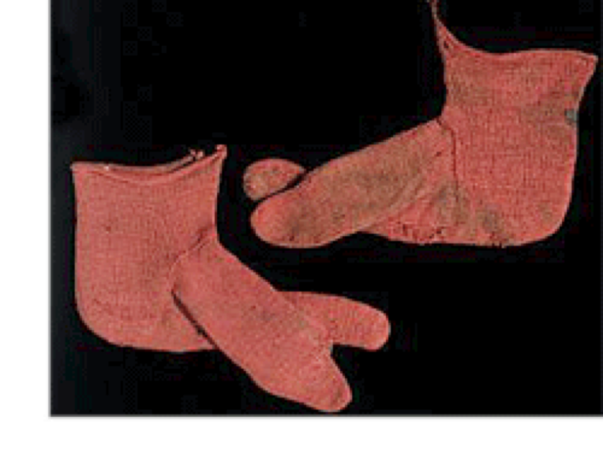

Slika 2: first knitted socks, Victoria and Albert Museum, London

The earliest example was these knitted socks, © Victoria and Albert Museum, London, circa 300-499, excavated from Egypt at the end of the 19th century. According to the museum, they have been knitted in stocking stitch using three-ply wool and a single needle technique, similar to Nalbindning.
Nalbindning is described as an ancient Scandanavian technique used to produce woollen clothing from lengths of yarn and a single short needle. This method created a tight weave which was suitable for felting and therefore, provided maximum protection from the cold. While this is not considered knitting, it is suggested it may be its precursor and certainly that of crochet-work. Evidence of the earliest knitting, using two needles, is believed to come from Egypt in the eleventh century, where more knitted socks were found. (k)

Knitting guilds
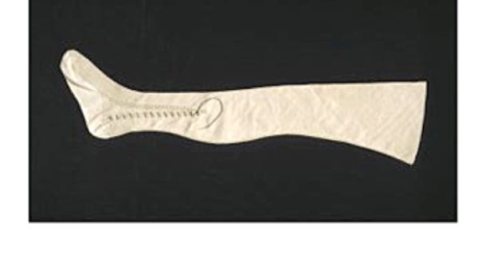

Slika 3: fashionable knitted socks from France

Fashionable knits were known in France as early as the 1420s. It is also known that knitting guilds, exclusively male and with structured apprenticeship systems, were formed in Europe in the 1400s. These knitting guilds appear to have been established to improve the quality of the profession and to attract a wealthier and more stable clientele.

From the Elizabethan period in Briton, knitting history is easier to determine. The development of knitting was driven by the fashion of the time, in particular fitted stockings worn by the men under short trunks. These stockings were exported to many other parts of Europe.
During the 17th century, knitted stockings continued to be very popular and could be beautifully knitted and finished with embroidery as shown in this example, © Victoria and Albert Museum, London, cca. 1660 - 1670. (k)

Knitting for Victory -- World War II

On December 7, 1941, the Japanese bombed Pearl Harbor, and America entered World War II. At home, more and more Americans picked up their needles to knit socks, mufflers, and sweaters to keep American soldiers warm.(m)
Many of the earliest knitters for World War II had knit for Victory as children or young adults during World War I. Knitting was for them a natural and immediate response to war. “The men hardly have time to grab their guns before their wives and sweethearts grab their needles and yarn,” claimed Time on July 21, 1940. Knitting provided warmth and comfort for the soldier and therapeutic distraction for the knitter.(m)
After the war years, knitting had a huge boost as greater colors and styles of yarn were introduced. Many thousands of patterns fed a market hungry for fashionable designs in bright colors. The twinset was an extremely popular combination for the home knitter. It consisted of a short-sleeved top with a long-sleeved cardigan in the same color, to be worn together.(m)
Girls were taught to knit in school, as it was thought to be a useful skill, not just a hobby. Magazines such as "Pins and needles" in the UK carried patterns of varying difficulty including not just clothes, but also blankets, toys, bags, lace curtains and items that could be sold for profit.(m)

A Decline

The popularity of knitting showed a sharp decline during this period in the Western world. Sales of patterns and yarns slumped, as the craft was increasingly seen as old-fashioned and children were rarely taught to knit in school.
The increased availability and low cost of machine knitted items meant that consumers could have a sweater at the same cost of purchasing the wool and pattern themselves, or often for far less. (l)

Early 21st Century Revival

The 21st century has seen a resurgence of knitting. Natural fibers from animals, such as alpaca, angora, and merino, and plant fibers, chiefly cotton, have become easier and less costly to collect and process, and therefore more widely available. Exotic fibers, such as silk, bamboo, and qiviut, are growing in popularity as well. The yarn industry has started to make novelty yarns which produce stunning results without years of knitting experience. Designers have begun to create patterns which work up quickly on large needles, a phenomenon known as instant-gratification knitting. (i)
As time and technology change, so does the art of knitting. The Internet allows knitters to connect, share interests and learn from each other, whether across the street or across the globe. Among the first Internet knitting phenomena was the popular KnitList with thousands of members. In 1998, the first online knitting magazine, KnitNet, began publishing. Blogging later added fuel the development of an international knitting community. (i)
Although nobody knows exactly where true knitting started, it would seem that knitting was probably spread by Arabian sailors and merchants who traveled throughout the Mediterranean. Then, evidently, traveling Catholics quickly spread it throughout Europe. True knitting, as we know it, is a relatively recent craft. Crafts similar to true knitting, such as cross-knitting and nalebinding, however, have a very long history, dating back to before the birth of Christ. They evidently were practiced in a lot of different countries and cultures too, from Japan to Egypt to Peru. Knitting clearly filled a need in people's making of garments which is still continuing and growing. (i)

History of hosiery in Slovenija

Until the middle of 18th Century people were knitting hosiery, gloves, caps at home for theirown needs and for market were tended in guilds united craftsmans. (h)
»Craft can be manufactoring, processing or service economic activitie. Craft is composed from craft sector and people who are professionaly qualifed who are called masters. They have also masters licence for their proffesion.« (5) Craftsmans were uniting into guilds until the middle of 19th century .
One of the oldest craftsmanship was knitting in which clothes were produced from woolen yarn by needles. The basic conditions for the development of this craft were excelent in Slovenia, since wool production was one of the most common farm activities. Woollen socks have always been the most representative items of knitwear, along with gloves, caps, sweaters, cardigans and, in recent times, coats and two- or three – piece ladies apparels. A new craftmanship, hosiery, has developed from knitting socks for domestic use. It was best developed in the upper valley of the Sava river, and in the area between Tržič and Jesenice. At the first region they were knitting mainly annual socks and at the second region they were knitting mainly winter socks. Knitting socks for sale was also known in Višnja Gora and its vicinity. The main hosiers center was Tržič, where they establish a hosiery fraternity in the first half of 18th century and worked in guilds regulations since 1756. Knitting hosiery was a craft that employed mostly man and than women and children. Also shepherds were knitting when they were at the pasture, if we can believe to folk tradition, for which we do not have enough sources that we could check. In the second half of 19th century there was between 600 and 700 hosiery knitters in Tržič. There were also a few craftsmans, who gave themselves a title master of hosiery. All hosiers` craftsmans were united into a hosiery fraternity. Despite contradicting they were working as real guild. Hosiery craftsmans in Tržič and other knitters were knitting in different patterens, which they have names for. So they were knitting rooster, fish bone, spruce, bishops` hat, grid, peacock feather, heart and others. They have also painted their products, mostly with red, blue and green or they let products in their natural colour of wool. It is interesting that they were using natural colours and mix them with urine instead with chemicals. Coloured and than washed socks were dryed on the wood casts in a shape of a leg that socks did not shrink. They were drying socks outside in hot weather or in the summer, therefore were houses in Tržič, where were many hosiery craftsmans, literally covered with drying socks. In the winter they dried socks in special area where they put wood casts on special wood shafts.
Knitting craft started to decline at the checkpoint between 19th and 20th century, when their work died down, becouse of competition of machines and industrial products. However, diverse knitting techniques have been preserved in various parts of Slovenia. The knitting tradition is also carried on in several big factories, such as Almira in Radovljica or Rašica in Gameljne near Ljubljana, and in numerous smaller and medium-sized knitwear workshops. As part of home crafts, knitting woolen socks has been preserved in the Gorenjska region, becouse of its wealthy supply of domestic wool. There was very developed sheep farming. are Well known knitters are Marija Pezdirnik, from the village of Mojstrana, and Helena Pratnekar, from Mežica in the Koroška region. (3,4,f,g)
With reconstruction of former knitting craft, we want to show in what conditions the craftsmans worked in the middle of 20th century.(h)
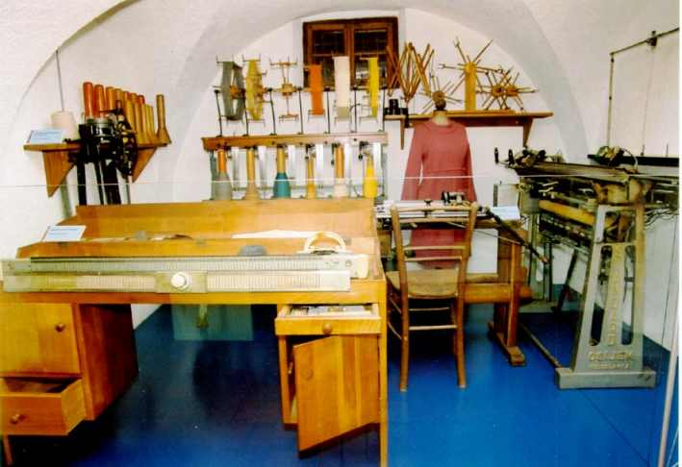

Slika 4: reconstruction of former knitting craft

Speciality are socks with studes. »Patternedly or knotedly knitted wool or cotton socks, which weared country women almost in all Slovenian teritory at the and of 19th century. Example for that socks were lacyly knitted women socks, which were weared in high society from Baroque to second world war. They were Co-designed by great knitting knowlidge, becouse of instituting obligatory school in 1869. In 20th Century knotedly knitted wool or cotton socks became a part of national costumes.« (5)
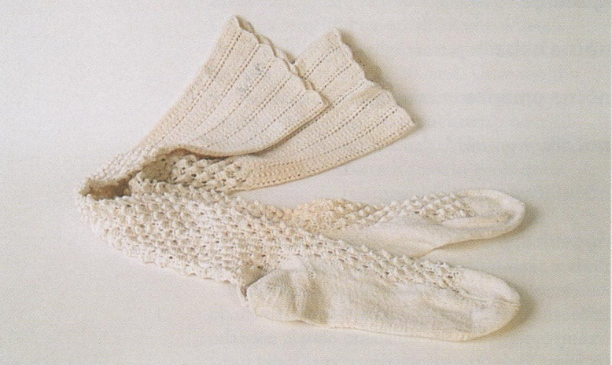

Slika 5: socks with studes

There is a museum in Tržič, which part is also Kurnikova hiša. This is gorenjska country house with characteristic of craft. After tradition the men were preserveing kolar craft and women were preserveing hosiery craft in this house. (e)
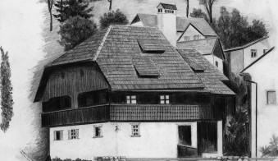

Slika 6: Kurnikova house

First factories of knitwear and socks in Slovenia

Knitting was idustrialized at the checkpoint between 19th And 20th Century, mainly between both wars.
In the 1899 Dragotin Hribar found first factory of knitwear and socks, in ljubljana. Motive power was from water wheel from Ljubljanica. Factory had 36 automatic and 40 manually machines and machine for dyeing. Between first world war the factory stood, after war the factory renovated its functioning and expanded. In the 1923 they removed wather wheel from Ljubljanica and replace it with steam engine. They modernized factory and reorganized to electric motive with theirown power plant in 1927. The factory produced knitwear and socks. In 1938 produced 127 000 dozen socks and large amount of knittwear. Until 1938 the factory employed about 170 workers.
Franc Lajovic, knitwear and knitted fabrics tricot, Litija. This company founded Franc Lajovic in 1911. The company employed 20-25 workers.
Josip Kunc & Co., factory of fabric and knittwear, Ljubljana, Poljanski nasip. The company was founded in 1921 by wholesaler Franc Urbanc and brothers Karl and Josip Kunc. The factory produced knitwear and it employed 140 workers.
Ika, mechanical factory of knitwear, d.z.o.z., Kranj. The company was founded in 1923. The factory produced knitwear, socks and knitted fabrics tricot. It had 165 knitting machines. At the end of 1937 factory stopped working and it was deleted from register.
First knitting factory in Maribor, d.z.o.z., Maribor.The company was founded in 1923. Ivan Reichman from Dunaj founded it. Factory produced knittwear. Annual production was 1400 dozen knitwear. There were employed 20-30 workers.
Polzela, factory of knittwear, d.z.o.z., polzela. The company was founded in 1926 by: Franc Dolenc; merchant from Škofja Loka, Josip Javornik; wood merchant from Žalna, dr. Alojz Kobal, lawer from Ljubljana, Viktor Meden; industrialist from Ljubljana;dr. Ernest Rekar, wood merchant from Jesenice, Ivan Rus; wood merchant from Loški potok. Already next year they sold all their shares. First half of shares went to Dunavska banka,d.d., Beograd and second half went to Teodor Reiser and Štefanija Reiser. The factory produced different tipes of socks. Annual production was 200 000 dozen socks. The company employed about 300 workers in 1938 and 1939.
Factory for producing and manufactoring knitted, embroidered and weaved fabric Ivan Savnik, Kranj. The company was founded in 1936. Factory produced 6421 dozen of knittwear and employed 72 workers. (6)
The development in textile industry in Slovenia was improving until 1939. After that year was development in industry very disrupted becouse of war conditions, which caused problems with importing of main raw materials. In the year 1940 there was a lack of cotton and cotton yarn. Therefore many factories limited their production size, restricted nubers of employees and reduced numbers of working days to five and less. In 1939 was 17 factories, which employed around 18,213 workers. Textile industry was the most important branch of the economy between both wars. In period since 1987 until 1991 the production was decreased annually for 10 percent to 20 percent (from 44.3 to 21.3 million pairs) and in the period since 1991 until 1992 the production was decreased annually for 30 percent to 50 percent. The smallest production size was reached in 1992 and stayed on this level until 1995. In 1996 the production size was triple increased. The reasons for such movements were loss of Yugoslavian market, world economic crisis and changes in economic system. Companies had to adjuste situations on the market. Consequently companies were decreasing production size or completely gave up. Some companies went to bankrupt and others had temporary redirected into service activities of sewing socks. The movement on the market was very diverse, therefore is hard to predict further development of hosiery.(1, 6)

History and present in Polzela d.d.


Slika 7: logotype of Polzela d.d.

The most specialised producer of hosiery in Slovenia was polzela, d.d. and still is. Beginings in company Polzela d.d. was in 1927, when Swiss industrialist with 60 employees started knitting first socks in Polzela. Already earlier in the second world war there were 360 workers and production was 1.8 million pairs of socks. In 1950 they made first socks of artificial silk, which were then fashion hit. In the early sixties they began to export in large amounts. They caught also a fashion with mini skirts, which revals beautiy of women legs. Polzela was first company in Yugoslavia, which made pantyhose with name Peggy. That name is still synonym for good quality pantyhose. After political independance in Slovenia, Polzela avoided problems because of dawnfall of big market, with encreased expot. They got a licence for products made of microfibres and Lycra yarn, which were mixed with natural fibres. Polzela now export 70 percent of their products mostly in Germany, Switzerland, Austria, states of Benelux, Sweden, Russia, Croatia, Serbia, Bosnia and Herzegovina and Macedonia. In the past two years they have also gained a market in Kanada. They work with high-tech machinery and they are making 23.000 pairs of socks. They have got developed inter control in production and high control in quality of their products. They invest a lot in ecological production. Since April 1997 they have been operateing according to standard Oko-tex 100, which requirement is humane and ecological protection of consumers. Sice February 2001 they have been operateing with ISO standard 9001. Polzela d.d. is manufacturer and provider of women, men and children socks and it is the biggest producer of hoisery in Europe. The company follows innovations and demands of market for contemporary materials. (7)

History of knitting machines (intended for sockings)
In 1589 an English vicar William Lee in Nottingham near Calvertona invented mechanized knitting machines. For many years he studied the movement of women during the development period loops, hand-knitting. The effective mechanical repetition of movements reached a solution in the whole loop type of complication at the same time, which is required under the knitting needles built system i.e. needles. The first was knitting machines sharing 8E, intended for making coarse wool socks. Surface on knitted socks parts were assembled by sewing. In years 1596-1597 has produced a machine sharing 20E (machine had 20 needles in two inches instead of 8 needles per inch), suitable for the manufacture of the finest silk stockings. The design activity Lee`s knitting machines is still the cornerstone of modern knitting machines and lacework. (8)
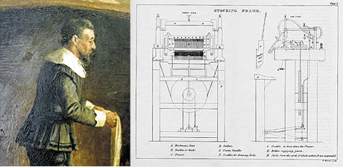

Slika 8: William Lee, pioneer or the illustrated knitting frame
Skilled manual knitters collected guild and trade associations, in the 15th century unfolded at a speed of 120 to 150 stitches per minute. At the turn of the century was the speed of knitting in the first knitting machines 500 to 600 stitches per minute, the advanced knitting machines for silk stockings but already from 1000 to 1500 stitches per minute. Compared with today's circular knitting machines a large number of knitting systems that make up to 20 million stitches per minute, the productivity of the knitting in 400 years has increased by 150000 times.
Knitting industry began to develop rapidly in the 17th century, as it worked in England from 700 to 800 knitting machines, by the year 1727, the number rose knitting machines the 8000th.
In the early 19th knitter century, due to overproduction of the economic crisis. Blame has been attributed to machine, so a group of people led by Ned Ludda between their actions was a large part of knitting machines. The improvement of the situation was until the second half of the 19th century, when technical progress could not be stopped. William Cotton in 1864 presented his first.
Automatic knitting machines, which wiped out the principle of operation Leejevega knitting machines. Simplify and expedite the operation of the machine, the production effect is further increased the number of simultaneously driven needles. The so-called, full-fashioned knitting machines was soon started to use for the manufacture of welded socks. Circular knitting is socking industry entered only in the 19th century. The first operational circular knitting machines is in 1816, the so-called "tricoteur".
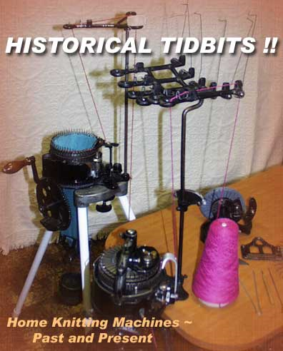
After the invention latch needles in 1849 were still many improvements needed before the circular knitting machines with latch needles can seriously harm those with knobbly needles. The application of ex wool, silk and cotton and regenerated cellulose fibers in the then stage of development were seamless tubular knitted socks in the ankle loose. Constructors circular socking knitting machines not find incentives for the development until 1946, when the market reign polyamidealuminium nylon fiber and this has opened the way for development socking circular machine. (1,9)

Slika 9: home knitting machine

To the development of hand spinning machine at home

Museum studies with today's technology lead to very interesting finds. Primitive finds knitting techniques date back to prehistory. This was shown with a needle and short pieces offiber in early 1970. Further documents are about three parts of knitting. In the old Syrian city that was abandoned by the Persians in 256 BC, the study showed that even then manually unfolded with two knitting needles. The development has been and still is in hand knitting with one to two needles. Until they have developed a framework for knitting, circular knitting machines and socking machines. (a)
Northville he invented the first domestic machine around 1867, the so-called Lamb Knitting Machine. Thus articulated 84 needle machine with six-inch long needles, which weighed about 15 kilograms. In 1870 developed the so-called Crane Knitter system in which they found for a square groove 106 of needles that can shift forward or backward. This was one of many stocking knitting machines of the time, which included both snovane as circular socks on the machine. At the end of 1800s, the producers started to market knitting machines for home use. (c)
Knitting machines in the industrial revolution
There are many types of knitting machines from simple to very complex and electronic. And you produce various types of knitted fabrics, usually either flat or tubular, and different levels of complexity.
The machine had done much work in twelve hours, as it could make ten people at the same time manually. The fact that the people were directed by night and day, that make up what he did one machine in one day. (b)

Knitting machines today
Masako Hagiwara invented the first home manual knitting machine in 1924. This requirement, exemption from all the needles, yarn by hand. The first European home Passapje machine was manufactured in 1939 in Zurich. Most domestic knitting machine is designed to work on the basis of stitch construction. Home machines are used to 200 kavljnih needles that get finest seams, standard or bulky needle. Home knitting machines using weft knitted method gave similar manual knitting fabric. Knitting material is faster than hand-knitting, because the needles are usually two levels, which are in hand and each stitch is tailored to individual movements in a row. Knitting machine as part of a series of loops in a single movement. (10,c)
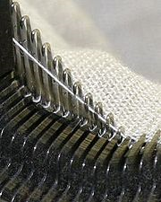

Slika 10: modern industrial knitting machine in action

Shared history of knitting machine

It is difficult to define precisely the origin of knitting. Hand-knitting the early invention. How this art has been obtained by men and in which country it originates is still a mystery. However, some believe that this art originates in Persia, while others claim Israel, Jordan and Syria, its place of origin. There are others who argue that this vessel originates in the mountains of North Africa. History or origin of knitting can be studied in different centuries or periods as follows:
4th century
Previously known knitted pair of socks was found in Egyptian tombs, dating back to 4th century BC Today it is known that they were hit early work in Nalebinding. Nalebinding is an old vessel, which involves creating fabric from thread by making multiple knots or loops, and is done with a needle made of wood or bone.
14th century
The art of knitting seems to have advanced in Western Europe in the 14th century. It is said that in Europe, hand knitting is an important industry that has evolved into a craft and advanced by 16th century. Hand knitting spread rapidly across Europe, in a few generations.
There is evidence of four survivors from the 14 images century, showing the Virgin Mary knitting, indicating that the vessel was aware of the activities of women.
16th century
In 1589, William Lee, a priest invented the first knitting machine knit 8 stitches per 1 cm in width. This was in the reign of Queen Elizabeth I. He worked nine years to develop a machine that could knit 20 stitches per inch for silk stockings. This machine has been remarkable in several ways: a by-product of thinking that used a completely different way of making familiar products, with fewer employees, unlike any other device and the first machine, which has focused on increasing productivity process .
The first machine produced coarse knitting - farmer hose. Thus, during this period, the production of socks has become very important to many British and they were sent to the Netherlands, Spain and Germany. It is also fashionable for men these days wear socks built in short trunks. Queen Elizabeth I wore silk stockings alone, which have been nicer, softer and much more expensive. (2)
17th and 18th century
After the invention of the first knitting machine, knitting art gradually took over guild organized cottage industry in the 17th and 18 century.

19th century
The Industrial Revolution that began in the late 18th century in Britain and spread throughout the world, plays a key role in the spread of spinning wool and cloth production in factories. Full-fashioned knitting machine was invented in 1864 by William Cotton of Leicestershire, England. This machine was part of the original Lee model. Also known as Lace Market, Nottingham City, dominated by the production of machine-knitted lace during the Industrial Revolution and the coming decades. In the 19th century, it was possible to use a knitting machine, and then circular knitting machines appeared on the scene.
20th century
Seamless hosiery were circular machines. England became famous for his socks. In fact, the word from an old sock English word "tube", which means a covering for your feet. Initially, cotton, wool, silk and rayon yarn later were used for the manufacture of socks. Then came nylon in 1940, when women prefer nylon hose. The use of nylon stockings fit better because of its stretchable properties. Later, in the UK, stockings came to be associated with all types of machine-knitted garments, which is also known as twists. In the United States, the hosiery products are still known as socks, panty hose and socks. Knitwear was mainly associated with women's fashion, but later, knitted sweaters, cardigans, shirts, men's underwear, sportswear, swimwear and also became popular.
21st century
Developments in the 20th century led to an increase in production speed of knitting machines, and offer a wider choice of knitwear pattern. (d)

CONCLUSION

In our seminar paper about knitting and hosiery, we learned much, becouse formerly we knew very little aboute it. Firstly we obtained that is not known exactly where was the beggining of knitting becouse there are many theories about it. And it is also a dilema about how were made first socks, if they were worked in nalebinding or in true knitting process. Furthere more we research about hosiery craft in Slovenia, which we obtained that was not very widespread aroun our teritory, the centre was Ttržič. But we have a very succesful factory of Hosiery in Slovenia, Polzela d.d., which is the biggest producer of hosiery in Europe. In long period there was homecraft knitting, later they discovered knitting machines although they were incompleted, in the later centuries they repaired it and complete it, so that they could raised production and quality.

SOURCES

Book sources:

Pavko Čuden Alenka, 2000, Tekstilec let.43, št.7-8, str. 277-288

Brackenbury Terry, 1992, Knitted Clothing Technology, str. 2-3
- Janez Bogataj, 1989, Domače obrti na Slovenskem, str. 177-178
- Janez Bogataj, 1999, Mojstrovine Slovenije- Srečanja s sodobnimi rokodelci, str. 144-145
- Uredil Angelos Baš, 2004, Slovenski etnološki leksikon, str. 366 in str. 375
- France Kresal, 1976, Razvoj tekstilne industrije v Sloveniji, str. 133-135 in str. 144
- Nataša Topovšek, 2006, diplomsko delo, Celostna grafična podoba v podjetju Polzela tovarna nogavic, d.d., Univerza v Mariboru, Ekonomsko-poslovna fakulteta

Internet sources:

http://www.theknittree.com/knithistory.html, 10.12. 2009

http://www.knit-a-square.com/knitting-machines.html, 12.12.2009

http://en.wikipedia.org/wiki/Knitting_machine, 12.12.2009

http://sourcing.indiamart.com/apparel/apparel-industry/knitted-garments-information/history-of-knitting/, 12.12.2009
- http://www.slovenia.info/si/arhitekturne-znamenitosti/Kurnikova- hiša.htm?arhitekturne_znamenitosti=225&lng=1, 10.12.2009
- http://www.rokodelstvo.si/dejavnost/pletenje, 10.12.2009
- http://www.drustvo-akcija.com/Nogavicarstvo,307,0.html, 10.12.2009
- http://164.8.33.113/tms/index.php?option=com_content&view=article&id=229&Itemid=170&lang=sl, 10.12.2009
- http://en. wikipedia.org/wiki/History_of_knitting
- http://ezinearticles.com/?An-Early-History-of-Knitting&id=804092
- http://www.knit-a-square.com/history-of-knitting.html
- http://www.theknittree.com/yarn-kits-patterns.html
- http://www.historylink.org/index.cfm?DisplayPage=pf_output.cfm&file_id=5722

Picture sources:
2) http://www.knit-a-square.com/history-of-knitting.html
3) http://www.knit-a-square.com/history-of-knitting.html
4)http://164.8.33.113/tms/index.php?option=com_content&view=article&id=229&Itemid=170&lang=sl
5) Uredil Angelos Baš, 2004, Slovenski etnološki leksikon, str. 366 in str. 375
6)http://www.slovenia.info/si/arhitekturne-znamenitosti/Kurnikova-hiša.htm?arhitekturne znamenitosti =225&lng=1,
7) Nataša Topovšek, 2006, diplomsko delo, Celostna grafična podoba v podjetju Polzela tovarna nogavic, d.d., Univerza v Mariboru, Ekonomsko-poslovna fakulteta
8) http://www.knit-a-square.com/knitting-machines.html
9) http://www.theknittree.com/knithistory.html
10) http://en.wikipedia.org/wiki/Knitting_machine

