INTRODUCTION, CULTURE, SOCIALIZING

Have you ever met foreign business partners?
How do you greet visitors? How do you introduce yourself and your colleagues?
Is handshake always necessary?
When addressing women do you use “Miss”, “Mrs” or “Ms”? What are other forms of address? How are names used in business in Slovenia?
How important is the first impression?
How can you make your visitors feel comfortable?
Can you make small talk?

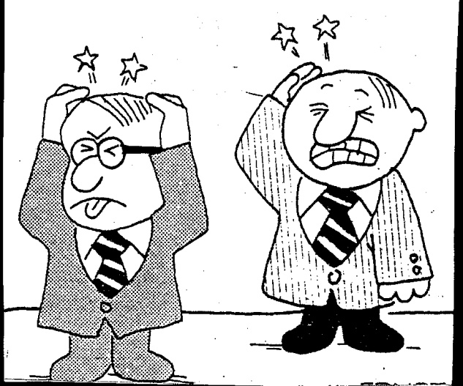

Read the text and comment on the following:
- Observations about many people from the United States
- Observations about the English
- An observation about Japanese children
- The meaning of lowering one’s eyes in Japan
- Why looking at someone for a long time may be considered disrespectful
- The meaning of widened eyes in Chinese culture

Eye contact
In many Western societies, including the United States, a person who does not maintain “good eye contact” is regarded as being slightly suspicious, or a “shifty” character. Americans unconsciously associate people who avoid eye contact as unfriendly, insecure, untrustworthy, inattentive and impersonal. However, in contrast, Japanese children are taught in school to direct their gaze at the region of their teacher’s Adam’s apple or tie knot, and, as adults, Japanese lower their eyes when speaking to a superior, a gesture of respect.
Latin American cultures, as well as some African cultures, such as Nigeria, have longer looking time, but prolonged eye contact from an individual of lower status is considered disrespectful. In the US, it is considered rude to stare – regardless of who is looking at whom. In contrast, the polite Englishman is taught to pay strict attention to a speaker, to listen carefully, and to blink his eyes to let the speaker know he or she has been understood as well as heard. Americans signal interest and comprehension by bobbing their heads or grunting.
A widening of the eyes can also be interpreted differently, depending on circumstances and culture. Take, for instance, the case of an American and a Chinese discussing the terms of a proposed contract. Regardless of the language in which the proposed contract is carried out the US negotiator may interpret a Chinese person’s widened eyes as an expression of astonishment instead of as a danger signal (its true meaning) of politely expressed anger.
(Simon Sweeney: English for Business Communication)
Discussion – what about some other areas of potential cultural misunderstanding?

- Distance when talking to people
- Gesture
- Greetings / goodbyes
- Humour
- Physical contact
- Presents
- Food and eating
- Rules of conversation and the role of silence

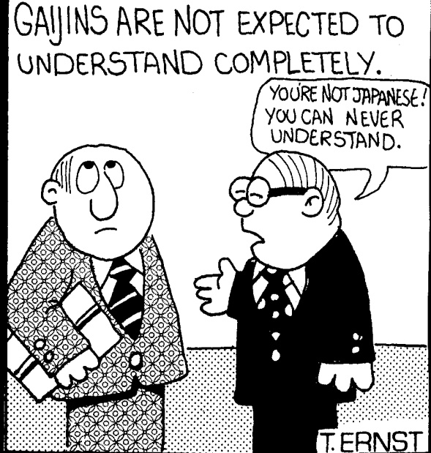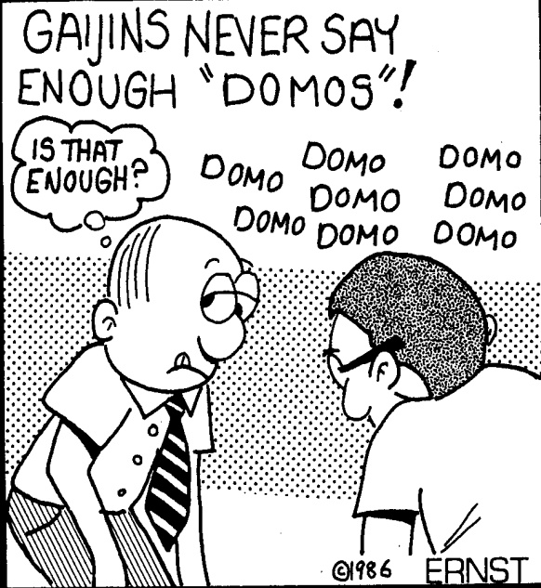

So…what is culture??

Cultural quiz

If a Japanese person gives you their business card, you have to
- Take it with both hands and study it carefully.
- Put it straight into your wallet or pocket.
- Write notes about them on it.

You cannot do business in Muslim countries
- On Wednesdays.
- On Fridays.
- On Sundays.

In the Middle East you have to give presents to business contacts
- In private.
- In public.
- Every time you meet.

If you are doing business with a German, you have to shake hands
- When you meet.
- When you leave.
- When you meet and when you leave.

A British professor was a guest lecturer at the university in an Islamic country. During his address, he unthinkingly insulted the audience by displaying a part of his body. What did he show the audience that was so offensive?
- His teeth.
- His left hand
- The sole of his foot.

Learning to speak a few words of the language of international clients, customers, and workers is:
- Generally a good idea as the effort communicates respect for the other person.
- Generally not a good idea because they might feel patronized.
- Generally not a good idea because they might be offended if a mistake is made in vocabulary or pronunciation.

If you are in a pub in England, you have to buy a drink
- For yourself.
- For everyone in the group you’re with.
- For everyone in the pub.
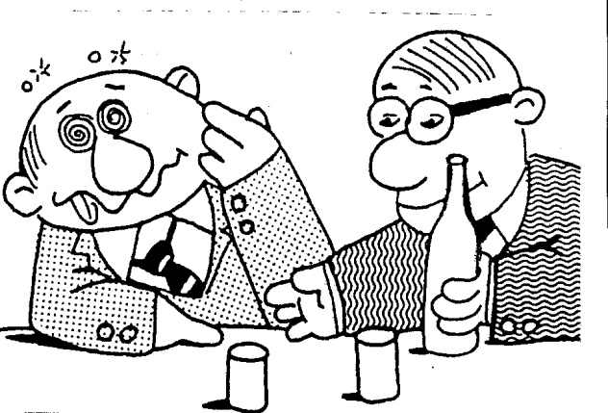

In a restaurant

Before taking foreign visitors to a restaurant make sure you are prepared to talk in English about:
- your professional field
- your company and business
- competition, the market, products and services
And also about:
- Your country, tourism, cultural events, etc.
- Education, the economy, transportation, etc.
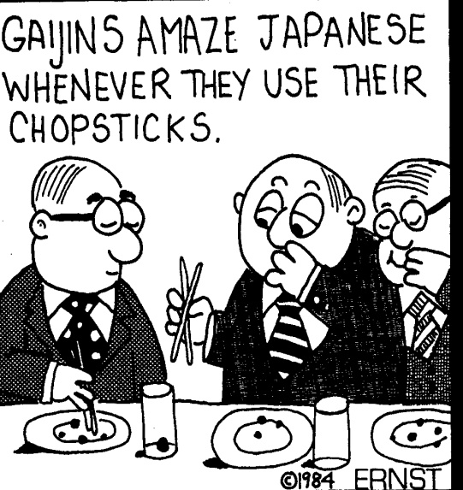

SOME USEFUL PHRASES

Inviting | Would you like to…  Would you be interested in going…  I’d like to invite you to have dinner this evening.
Responding | SAY YES  That would be very nice.  That is a very good idea.  Thank you. That would be a pleasure.  SAY NO  I’d like to, but I’m afraid…  That would be nice, but unfortunately…
Ordering | I’ll have…  I think I’ll have…  I think I’d like to try…  Shall we have a bottle of wine?
Thanking | It’s been a lovely evening.  Thank you very much for your hospitality.  I enjoyed it very much.
