Analiza in sinteza digitalnih vezij

11. Vaja: Meritve na 8-stopenjskem pomikalno-pomnilnem registru

Navodila za delo:
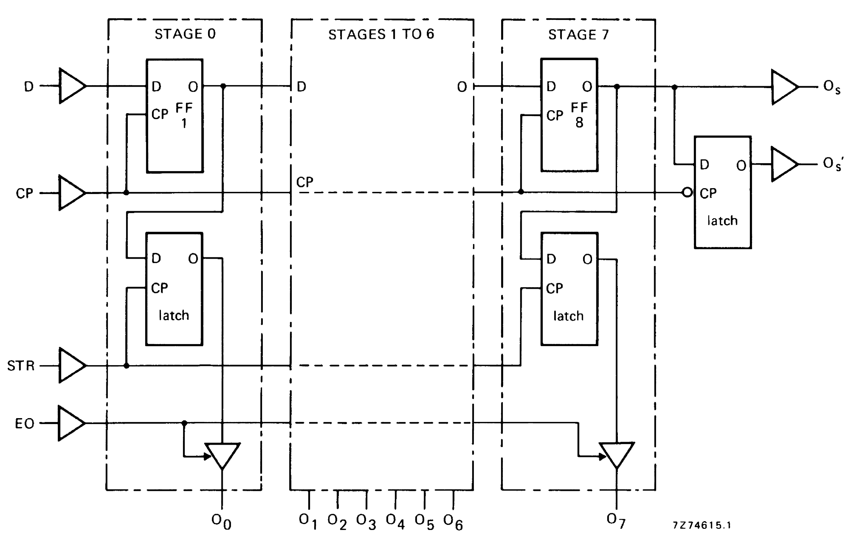
Temeljito proučite tehnične podatke za integrirano vezje HEF4094B. Na podlagi tehničnih podatkov spoznajte način delovanja, nato pa s pomočjo digitalne testne plošče preizkusite delovanje vezja. Vhode vezja Cp, D, STR in OE priključite na vhodna stikala, izhode pa na prikazovalnik z LED-diodami. Pravilnost delovanja preizkusite tako, da vpišete preko serijskega vhoda v pomikalni register nek izmišljen 8-bitni podatek (npr. 1-0-0-1-0-1-1-1) in z ustreznimi krmilnimi signali posredujete podatek na serijski in paralelni izhod. Vpisani oz. shranjeni podatek opazujete na LED-diodah. V nadaljevanju še preverite delovanje vezja v smislu obročnega registra, kjer povežete izhod O_{s}´ s vhodom D. Za opisano proceduro narišite časovne diagrame za Cp, D, STR, EO, O₀, O₁, …,O₇,O_{s} in O_{s}´.
Poenostavljena shema HEF4094B:
DESCRIPTION
The HEF4094B is an 8-stage serial shift register having astorage latch associated with each stage for strobing data from the serial input to parallel buffered 3-state outputs O0 to O7. The parallel outputs may be connected directly to common bus lines. Data is shifted on positive-going clock transitions. The data in each shift register stage is transferred to the storage register when the strobe (STR) input is HIGH. Data in the storage register appears at the outputs whenever the output enable (EO) signal is HIGH. Two serial outputs (Os and O’s) are available for cascading a number of HEF4094B devices. Data is available at Os on positive-going clock edges to allow high-speed operation in cascaded systems in which the clock rise time is fast. The same serial information is available at O’s on the next negative-going clock edge and provides cascading HEF4094B devices when the clock rise time is slow.

APPLICATION INFORMATION
Some examples of applications for the HEF4094B are:
• Serial-to-parallel data conversion
• Remote control holding register
Blokovna shema HEF4094B:
Razpored priključkov HEF4094B:
Narišite časovne diagrame za vse vhode in izhode glede na izbrani podatek za vsaj 10 taktnih impulzov.

Blokovna shema HEF4094B:

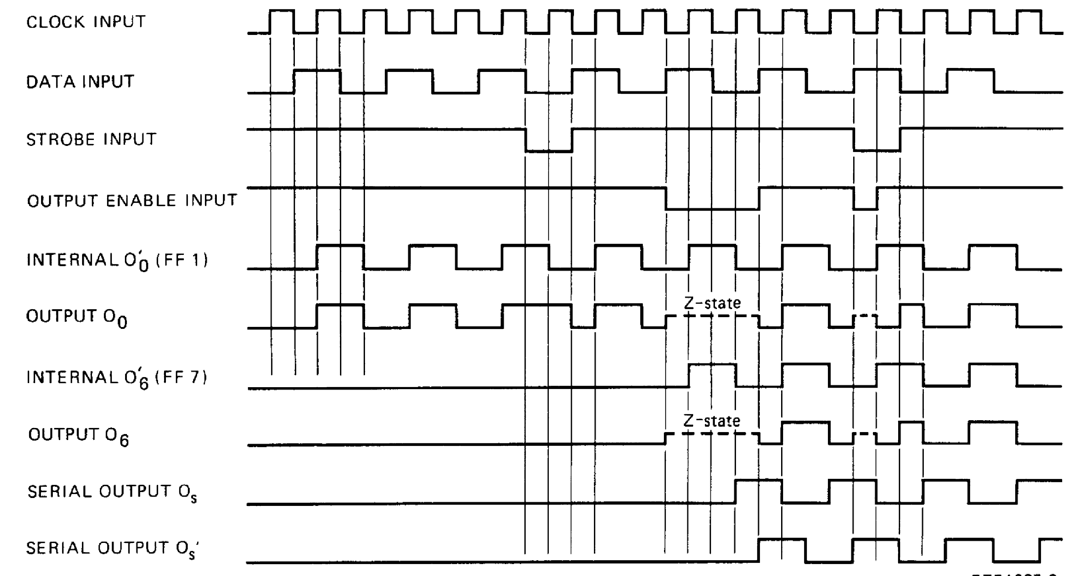
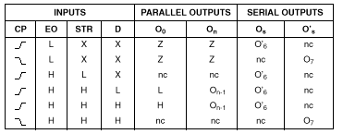
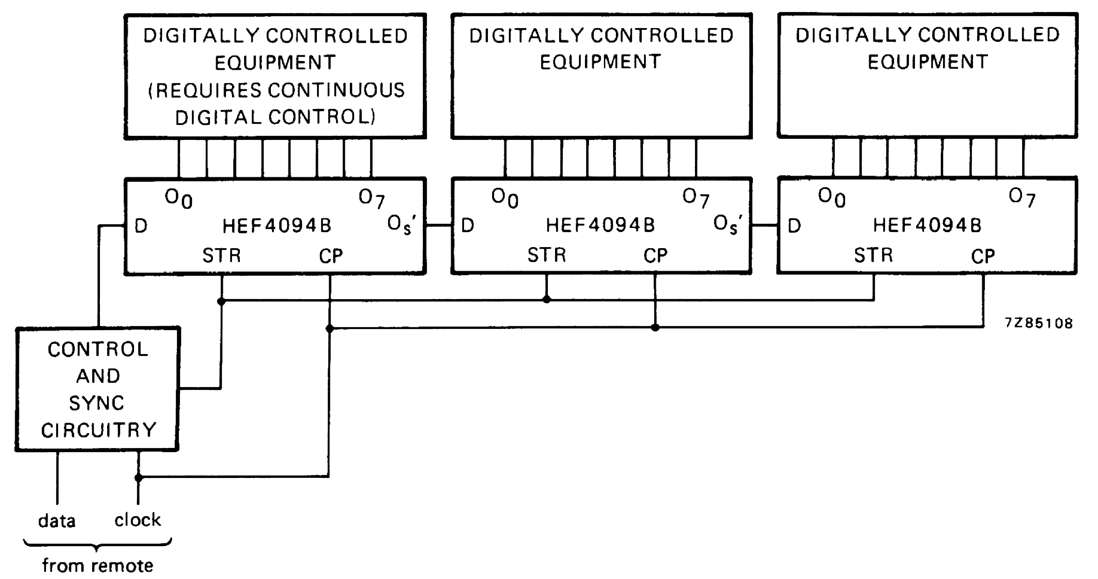
ČASOVNI DIAGRAMI:
Notes
1. H = HIGH state (the more positive voltage)
2. L = LOW state (the less positive voltage)
3. X = state is immaterial
4._ ∕¯= positive-going transition
5.¯\_= negative-going transition
6. Z = high impedance off state
7. nc = no change
8. O’6 = the information in the seventh shift register stage
At the positive clock edge the information in the 7th register stage is transferred to the 8th register stage and the Os output.

Tipična aplikacija:
control holding registe
FUNKCIJSKA TABELA:
Funkcijska tabela:

ČASOVNI DIAGRAMI:

