Unit 3. Computers
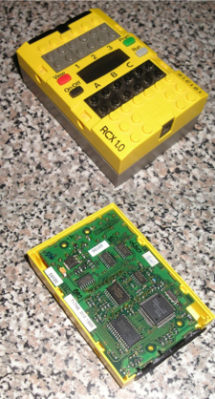

A Lego RCX Computer is an example of an embedded computer used to control mechanical devices. It is fully programmable.
A computer is a machine for manipulating data according to a list of instructions known as a program.
Computers are extremely versatile. In fact, they are universal information-processing machines. According to the Church–Turing thesis, a computer with a certain minimum threshold capability is in principle capable of performing the tasks of any other computer. Therefore, computers with capabilities ranging from those of a personal digital assistant to a supercomputer may all perform the same tasks, as long as time and memory capacity are not considerations. Therefore, the same computer designs may be adapted for tasks ranging from processing company payrolls to controlling unmanned spaceflights. Due to technological advancement, modern electronic computers are exponentially more capable than those of preceding generations .
Computers take numerous physical forms. Early electronic computers were the size of a large room, while entire modern embedded computers may be smaller than a deck of playing cards. Even today, enormous computing facilities still exist for specialized scientific computation and for the transaction processing requirements of large organizations. Smaller computers designed for individual use are called personal computers (PCs). Along with its portable equivalent, the laptop computer, the personal computer is the ubiquitous information processing and communication tool, and is usually what is meant by "a computer". However, the most common form of computer in use today is the embedded computer. Embedded computers are usually relatively simple and physically small computers used to control another device. They may control machines from fighter aircraft to industrial robots to digital cameras.
During the first half of the 20th century, many scientific computing needs were met by increasingly sophisticated special-purpose analog computers, which used a direct mechanical or electrical model of the problem as a basis for computation. These became increasingly rare after the development of the programmable digital computer.

How computers work: the stored program architecture
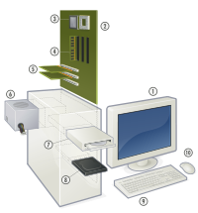

An exploded view of a modern personal computer:
1.Display 2. Motherboard 3. CPU (Microprocessor) 4. Primary storage (RAM 5. Expansion cards 6. Power supply 7. Optical disc drive 8. Secondary storage (HD) 9. Keyboard 10. Mouse
While the technologies used in computers have changed dramatically since the first electronic, general-purpose computers of the 1940s, most still use the stored program architecture (sometimes called the von Neumann architecture). The design made the universal computer a practical reality.
The architecture describes a computer with four main sections: the arithmetic and logic unit (ALU), the control circuitry, the memory, and the input and output devices (collectively termed I/O). These parts are interconnected by bundles of wires (called "buses" when the same bundle supports more than one data path) and are usually driven by a timer or clock (although other events could drive the control circuitry).
Conceptually, a computer's memory can be viewed as a list of cells. Each cell has a numbered "address" and can store a small, fixed amount of information. This information can either be an instruction, telling the computer what to do, or data, the information which the computer is to process using the instructions that have been placed in the memory. In principle, any cell can be used to store either instructions or data.
The ALU is in many senses the heart of the computer. It is capable of performing two classes of basic operations. The first is arithmetic operations; for instance, adding or subtracting two numbers together. The set of arithmetic operations may be very limited; indeed, some designs do not directly support multiplication and division operations (instead, users support multiplication and division through programs that perform multiple additions, subtractions, and other digit manipulations). The second class of ALU operations involves comparison operations: given two numbers, determining if they are equal, or if not equal which is larger.
The I/O systems are the means by which the computer receives information from the outside world, and reports its results back to that world. On a typical personal computer, input devices include objects like the keyboard and mouse, and output devices include computer monitors, printers and the like, but as will be discussed later a huge variety of devices can be connected to a computer and serve as I/O devices.
The control system ties this all together. Its job is to read instructions and data from memory or the I/O devices, decode the instructions, providing the ALU with the correct inputs according to the instructions, "tell" the ALU what operation to perform on those inputs, and send the results back to the memory or to the I/O devices. One key component of the control system is a counter that keeps track of what the address of the current instruction is; typically, this is incremented each time an instruction is executed, unless the instruction itself indicates that the next instruction should be at some other location (allowing the computer to repeatedly execute the same instructions).
Since the 1980s the ALU and control unit (collectively called a central processing unit or CPU) have typically been located on a single integrated circuit called a microprocessor.
The functioning of such a computer is in principle quite straightforward. Typically, on each clock cycle, the computer fetches instructions and data from its memory. The instructions are executed, the results are stored, and the next instruction is fetched. This procedure repeats until a halt instruction is encountered.
The set of instructions interpreted by the control unit, and executed by the ALU, are limited in number, precisely defined, and very simple operations. Broadly, they fit into one or more of four categories: 1) moving data from one location to another (an example might be an instruction that "tells" the CPU to "copy the contents of memory cell 5 and place the copy in cell 10"). 2) executing arithmetic and logical processes on data (for instance, "add the contents of cell 7 to the contents of cell 13 and place the result in cell 20"). 3) testing the condition of data ("if the contents of cell 999 are 0, the next instruction is at cell 30"). 4) altering the sequence of operations (the previous example alters the sequence of operations, but instructions such as "the next instruction is at cell 100" are also standard).
Instructions, like data, are represented within the computer as binary code — a base two system of counting. For example, the code for one kind of "copy" operation in the Intel x86 line of microprocessors is 10110000 ^{[4]}. The particular instruction set that a specific computer supports is known as that computer's machine language. Using an already-popular machine language makes it much easier to run existing software on a new machine; consequently, in markets where commercial software availability is important suppliers have converged on one or a very small number of distinct machine languages.
More powerful computers such as minicomputers, mainframe computers and servers may differ from the model above by dividing their work between more than one main CPU. Multiprocessor and multicore personal and laptop computers are also beginning to become available.^{[5][6]}
Supercomputers often have highly unusual architectures significantly different from the basic stored-program architecture, sometimes featuring thousands of CPUs, but such designs tend to be useful only for specialized tasks. At the other end of the size scale, some microcontrollers use the Harvard architecture that ensures that program and data memory are logically separate.
Computer types:

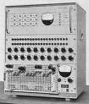 analogue computer | 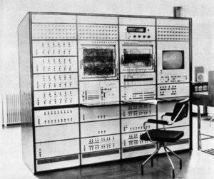 hybrid computer
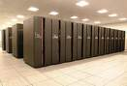 supercomputer | 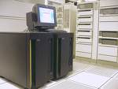 mainframe
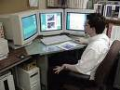 workstation | 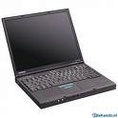 laptop
 roll-away | 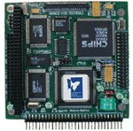 embedded
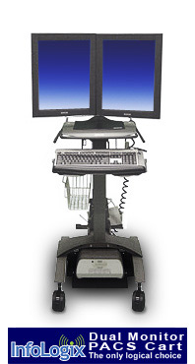 cart | 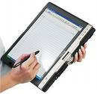tablet PC
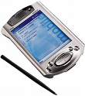 handheld | 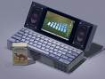 subnotebook
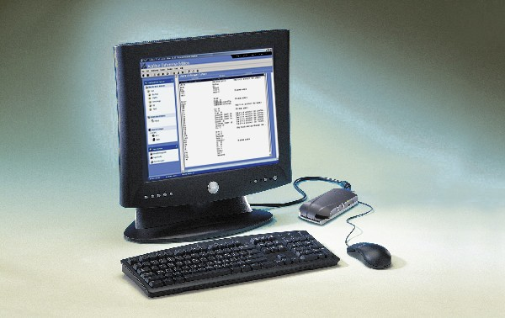  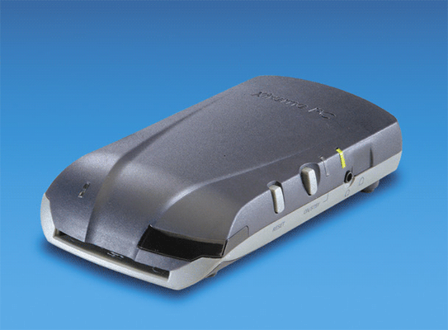 thin client | 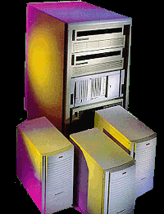 minicomputer
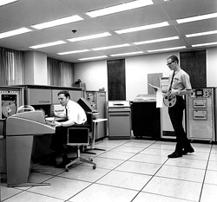 computer terminal | 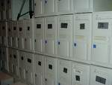 server

