INPUT DEVICES 2

Scanners

Input devices such as scanners and cameras allow you to capture and copy images into a computer.

A scanner is a peripheral that reads images and converts them into electronic codes which can be understood by a computer. There are different types.

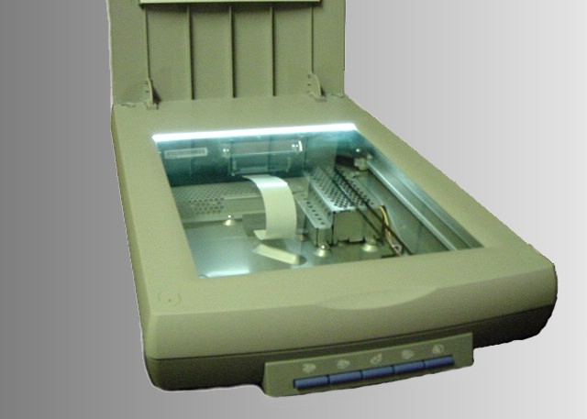 | A flatbed is built like a photocopier and is for use on a desktop; it can capture text, colour images and even small 3 D objects.
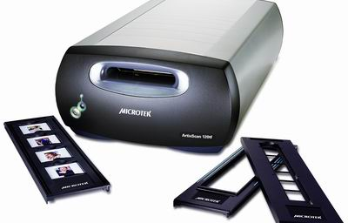 | A film scanner is used to film negatives or 35 mm slides – pictures on photographic film, mounted on a frame.
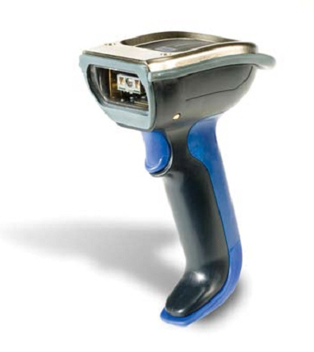 | A hand-held scanner is small T-shaped, ideal to capture small pictures and logos.
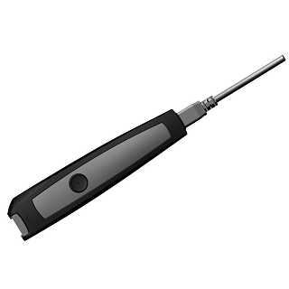 | A pen scanner looks like a pen; you can scan text, figures, barcodes and handwritten numbers.

Barcode scanners read barcodes on the products sold in shops and send the price to the computer in the cash register. Barcodes consist of a series of black and white stripes used to give products a unique identification number.
The resolution of a scanner is measured in dpi or dots per inch. For example, a 1.200 dpi scanner gives clearer, more detailed images than a 300 dpi scanner.
Most scanners come with Optical Character Recognition software. OCR allows you to scan pages of text and save them into your word processor; they can be edited.

Digital cameras
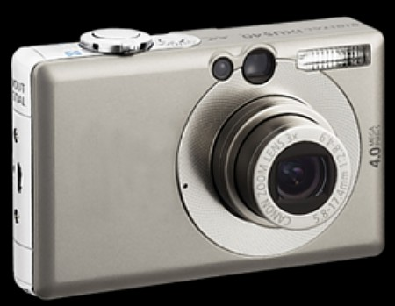

A digital camera doesn't use a film. Photos are stored as digital data (bits made up of 1s and 0s), usually on a tiny storage device known as flash memory card. You can connect the camera or memory card to a PC and then alter the images using a program like Adobe Photoshop, or you can view the images on a TV set. Many printers have a special socket so that you can print images directly from a memory card or camera.

Digital video cameras and webcams

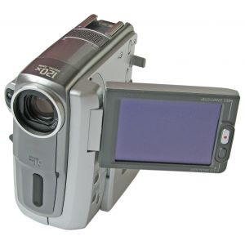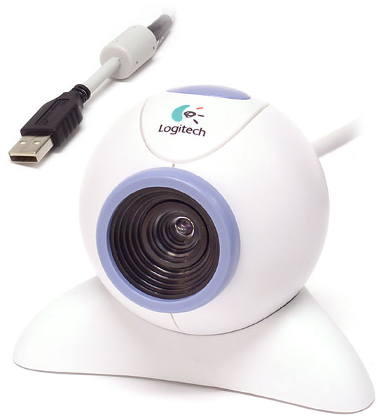
Complete the picture by: transfer, input, , output, processing.
A digital video camera /DV) records moving images and converts them into digital data that can be processed by a PC.
You can manipulate video images with video editing software. You can cut, paste, add effects, etc.
You can store or export the result., dlay it on a screen or create a DVD, email or put your movie on the Web.
Webcams (short for web cameras) let you send and receive live video pictures through the Internet. They are primarily used for video conferences – video calls – but they can be used to record photos and video onto your hard disk.

The resolution of webcams is expressed in megapixels (million pixels). Webcams connect to the PC via a USB or FireWire port; they display video at 24 to 30 frames (pictures) per second. Some include a headset with a microphone and earpiece.

A. Solve the clues and complete with the words from the reading.

1. Scanners and cameras are _______________ devices used to transfer images into a format that can be understood by computers.
2. A _____________ lets you copy photos and printed documents into your PC.
3. It has become one of life's most familiar sounds – the beep of the supermarket till whenever a __________________ is scanned.
4. If you need to scan 35 mm _________________ you should go for a dedicated 35 mm film scanner which concentrates all its dots into a tiny area.
5. This scanner has a resolution of 300 x 600 ______________ .
6. A _______________ scanner is small enough to hold in your hand.
7. A ______________ scanner is used to capture lines of text, barcodes, numbers.
8. Most digital cameras use flash ______________ cards to store photos.
9. _______________ scanners have a flat surface and take at least A4-sized documents.
10. To scan photographic negatives or slides you will need a ______________ scanner.

B. Decide whether the sentences are true or false.

1. The details detected by a scanner are not determined by its resolution. ______________
2. A barcode scanner is a computer peripheral for reading barcode labels printed on products. ______________
3. Scanners can not handle optical character recognition. _____________
4. A digital camera uses a light sensitive film instead of a memory card for storing the images. ________________
5. A digital video (DV) camera is used to take still photographs. _____________
6. Video editing software allows you to manipulate video clips on the computer. ______________ .

C. Complete the advertisement with words from the webcam section.

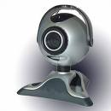WebCam Live Ultra

Having _________________ 1) with friends and family has never been easier or more enjoyable. You get the highest-quality audio and video, no matter which chatting solution you use. With the WebCam Live! Ultra, its CCD image sensor with 640 x 480 /VGA) resolution produces rich, vibrant colours. Combined with its _______________ 2) 2.0 HiSpeed connection, the result is top-quality, full-motion video at 30 _______________ 3) per second for all your web conversations, even in dimly lit rooms.
The WebCam Live! Ultra lets you do more. Let your voice be heard clearer than ever before with the included ________________ 4) unlike the built-in microphones in most other _________________ 5). Take still pictures at up to 1.3 _________________ 6) resolution (interpolated), and enjoy the many great features that accompany the bundled award-winning WebCam Center software, such as motion detection, remote security monitoring, timelapse video capture and much more.

What are the reasons for using a scanner at home or at work?
What basic features and the things you do with it?

D. A digital pen – Advertisement

Read the text and fill in the blanks with the words: sends, cables, computer, chip, digital, data, Internet.
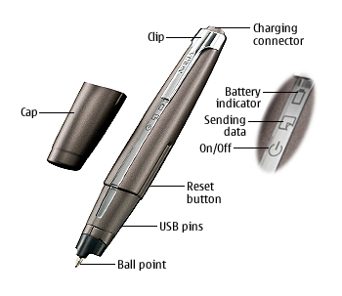
Anoto is a ________________ 1) pen that allows you to store and transmit anything you write or draw on paper to any ________________ 2). The components of it are: 1) a digital camera which scans the patterned paper, 2) an image processor, 3) a memory ______________ 3) which can store several written pages, and 4) a Bluetooth radio transciever which ______________ 4) the information to your PC, mobile phone or handheld computer. It also contains an ink cartridge so that you can actually see the characters and pictures that you are making. As you write or draw on the Anoto patterned paper, the digital pen converts your notes and diagrams into digital ________________ 5) which is stored and then transmitted to your computer or, by using a Bluetooth device such as a mobile phone, to another PC, database or the _______________ 6). Bluetooth is a wireless technology which doesn't need _________________ 7) in order to send and receive information.

Complete the following picture below after reading the text above.

pen
Mobile phone
PC
Another PC

What is common to all input devices?

OUTPUT DEVICES: PRINTERS

Technical details

A printer is a device that prints your texts or graphics on paper.

- The output on paper or acetate sheets is called printout or hard copy.
- A program in your computer, called the printer driver, converts data into a form that your printer can understand.
- A print spooler stores files to be printed when the printer is ready. It lets you change the order of documents in the queue and cancel specific print jobs.
- The output quality or resolution is measured in dpi or dots per inch.
- The speed of your printer is measured in pages per minute (ppm).
- In a network, users can share a printer connected to a print server, a computer that stores the files waiting to be printed.

Types of printers

A dot-matrix printer uses a group, or matrix, of pins to create precise dots. A print heading containing tiny pins strikes an inked ribbon to make letters and graphics. This impact printing technology allows shops, for example, to print multi-part forms such as receipts and invoices, so it's useful when self-copying paper is needed. It has two important disadvantages: noise and a relatively low resolution (from 72 to 180 dpi).

An ink-jet printer (also called bubble-jet) generates an image by spraying tiny, precise drops of ink onto the paper. The resolution ranges from 300 to 1200 dpi, suitable for small quantities or home use.

A standard ink-jet has a three-colour cartridge, plus a black cartridge. Professional ink-jets have five-colour cartridges, plus black; some can print in wide format, ranging from 60 cm up to 5 m, ( for printing advertising graphics).

Some ink-jets based printers can perform more than one task. They are called multi-function printers because they can work as a scanner, a fax as well as a printer. Some units accept memory cards and print photos directly from a camera.

A laser printer uses a laser beam to fix the ink to the paper. A laser works like a photocopier; a powder called a toner is attracted to paper by an electrostatic charge and then fused on by a hot roller.

Laser printers are fast and produce a high resolution of 1200 to 2400 dpi, so they are ideal for businesses and for proofing professional graphics work.

Lasers use a page description language or PDL, which describes how to print the text and draw the images on the page. The best-known languages are Adobe PostScript an HP Printer Control Language.

A professional imagesetter is a typesetting printer that generates very high resolution output (over 3540 dpi) on paper or microfilm. It's used for high-quality publications.

A plotter is a special type of printer which uses ink and fine pens held in a cartridge to draw detailed designs on paper. It's used in computer-aided design, maps, 3 D technical illustrations, etc.

A. Complete these sentences with the words in 'Technical details'.

1. The differences in ________________ are noticeable; the more dots per inch, the clearer the image.
2. A print resolution of between 600 _____________ and 2400 _____________ ensured that even text as small 2 pti was legible.
3. Passengers with and electronic ticket will need a _______________ of ticket confirmation or boarding pass to be admitted to secured gate areas.
4. The key advance of recent years is printing speed: the latest generation of ink-jets prints black-and-white text at 15 ______________________________ (_________________).
5. With appropriate software, you can view the images on a computer, manipulate them, or send them to a _________________ and produce excellent quality colour copies.
6. A __________________ is a dedicated computer that connects a printer to a network. It enables users to share printing resources.
7. A __________________ is a utility that organizes and arranges any documents waiting to be printed.
8. In computers, a __________________ is a program installed to control a particular type of printer.

B. Choose the most suitable type of printer for these situations from the descriptions in 'Types of printers'.

1. a home user who wants to print text documents and family photographs
2. business people who need to print in large quantities at high quality in an office
3. engineers who want to make detailed line drawings
4. professional typesetters in desktop publishing (to publish catalogues and magazines)
5. a company that wants to print carbon copies of bills and receipts

C. Find the terms which correspond to these definitions.

1 the container that holds the ink in an ink-jet printer
2 powdered ink used in laser printers
3 small needles that press on the inked ribbon to make the characters on paper
4 printer technology that produces text and pictures by hammering pins against a ribbon and the paper
5 a language that tells a printer how to print a document
6 a peripheral which combines a printer, a fax machine and photocopying and scanning capability into one device

Describe the characteristics of the printer that you have at home.

What is in the picture?

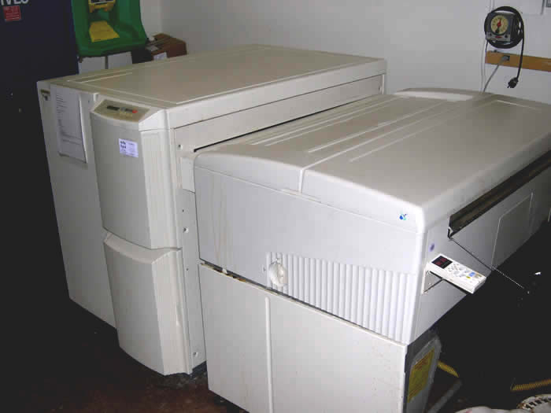 | 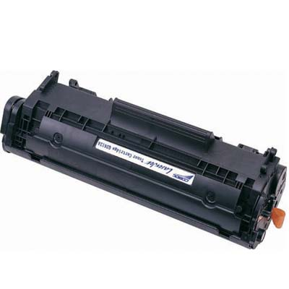
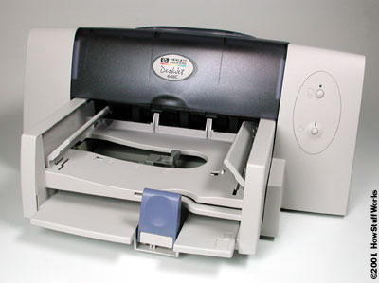 | 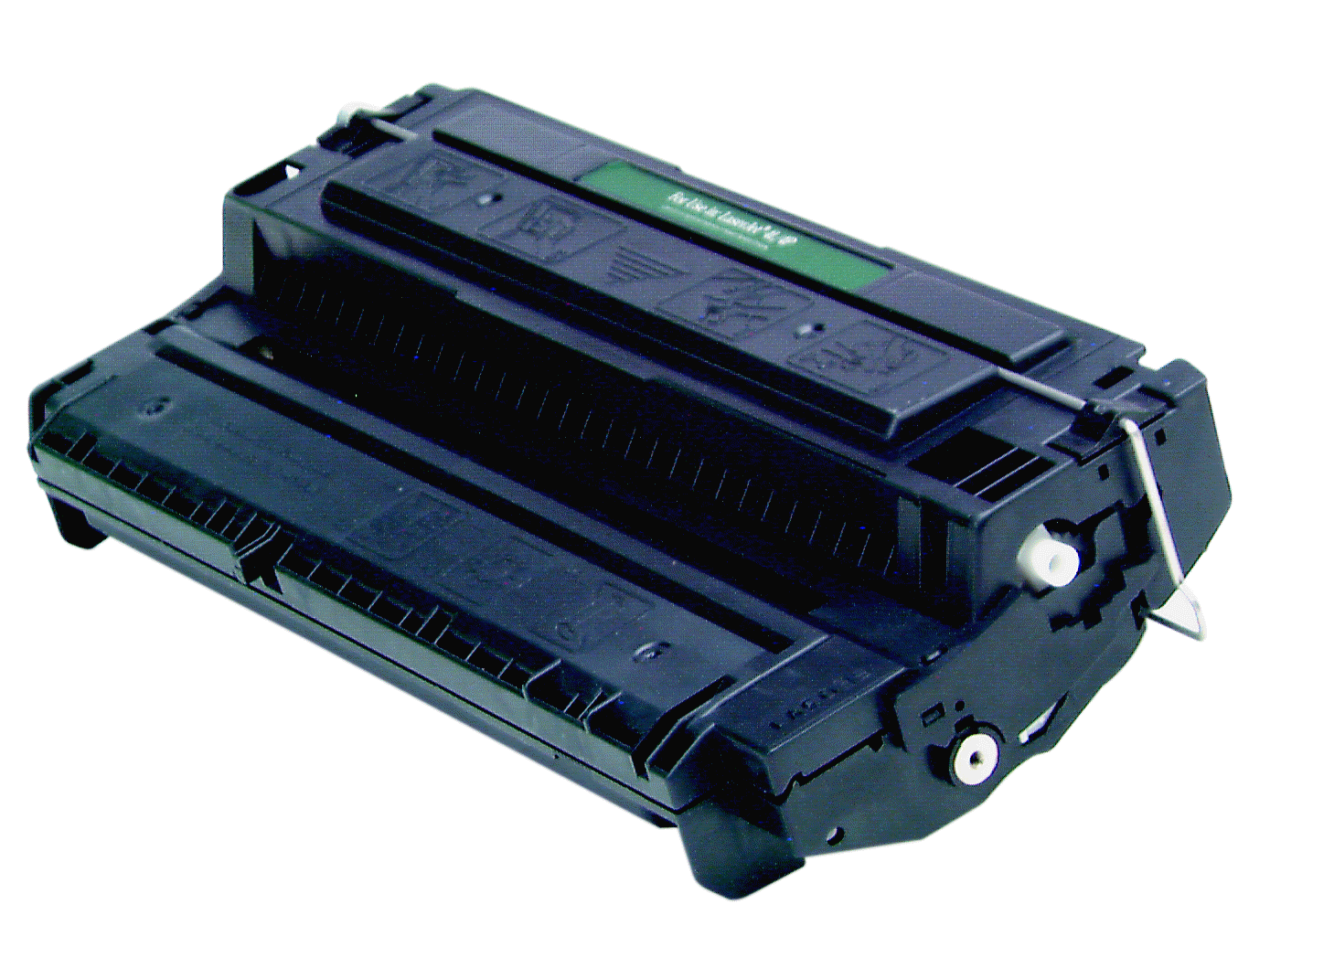
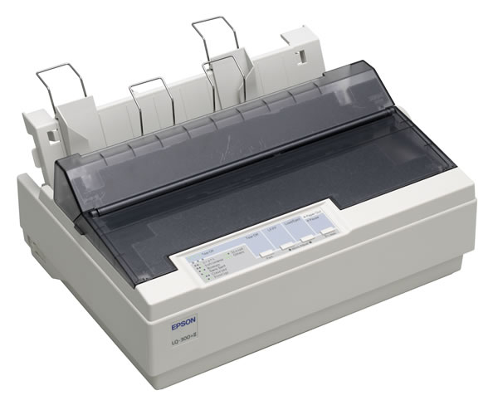 | 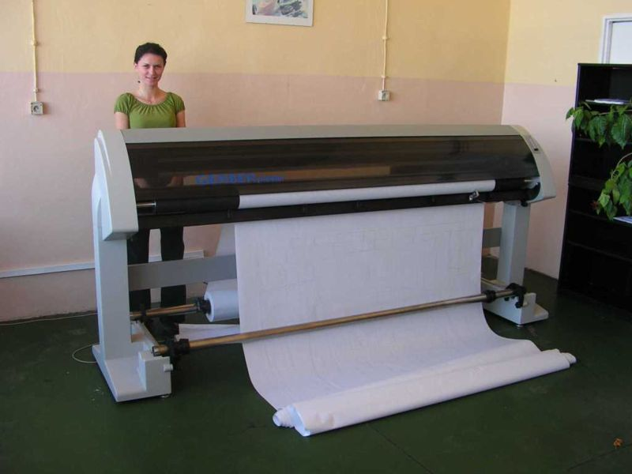
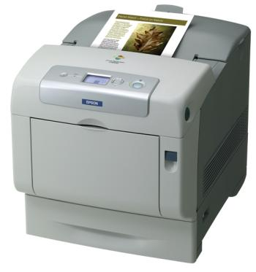

Tell to the class the features of each printer.

OUTPUT DEVICES : DISPLAY SCREENS

CRTs and LCDs

The screen on a computer is often known as the monitor, or VDU (Visual Display Unit). Inside the computer, there is a video card which produces images and sends signals to the monitor.

When choosing a monitor, you have to take into account a few basics.

- Type of display – the choice is between a CRT or an LCD screen.

The Cathode Ray Tube of a monitor is similar to a traditional TV set. It has three electron guns (one for each primary colour; red, green and blue) that strike the inside of the screen which is coated with substances called phosphors, which glow and create colours. CRTs are cheap, but they are heavy, can flicker and emit radiation.

A Liquid Crystal Display is made of flat plates with a liquid crystal solution between them. The crystals block the light in different quantities to create the image. Active-matrix LCDs use TFT (Thin Film Transistor) technology in which each pixel has its own transistor switch. They offer better quality and take up less space, so they are replacing CRTs.

- Screen size – the viewing area is measured diagonally; in other words, a 17'' screen measures 17 inches from top left corner to the bottom right.

- Resolution – the clarity of the image depends on the number of pixels (short picture elements) contained on a display, horizontally and vertically. A typical resolution is 1024 x 768. The sharpness of images is affected by dot pitch, the distance between the pixels on the screen, so a dot pitch of 0.28 mm or less will produce a sharp image.

- Brightness – the luminance of images is measured in cd/m² (candela per square meter).

- Colour depth – the number of colours a monitor can display. For example, a VGA monitor produces 256 colours, enough for home users; a SuperVGA can produce up to 16.7 million colours, so is ideal for photographic work and video games.

- Refresh rate – the number of times that the image is drawn each second. If a monitor has a refresh rate of 75 Hz, it means that the screen is scanned 75 times per second. If the rate is low, you will notice a flicker, which can cause eye fatigue.

A. Read the text on 'CRTs and LCDs' and then correct these false statements.

1. The images shown on a monitor are not generated by the video card.
2. All visible colours can be made from mixing the three primary colours of red, yellow and blue.
3. Typical CRT-based displays occupy less space than LCD displays.
4. Active matrix LCDs do not use a technology called TFT.
5. The size of the screen is measured horizontally.

B. Match each term with the correct definition.

1 phosphors a) the frequency at which a monitor renews its image, measured in Hz
2 LCD screen b) a flat-panel display which works by emitting light through a special liquid
3 pixel c) the space between a display's pixels
4 dot pitch d) the smallest element in a displayed image
5 refresh rate e) materials that emit light and produce colours when they are activated by an electron beam

C. Complete the specifications of this monitor and read again 'CRTs and LCD's if necessary.

The new Paintview Xt-85 combines television and a computer _______________ 1) in one display.

Type of display | Flat panel LCD
2) ................................ | 19 inches
3) Display ................................ | 1280 x 1024 pixels
Dot pitch | 0.294 mm
4) .................................. | 16.7 million colours
Cotrast ratio | 1000:1
5) ................................. | 450 cd/m²
Built-in TV tuner | yes
Audio | Two 3-watt speakers and a 5-watt subwoofer, headphone jack
The picture-in-picture function allows you to watch more than one program at the same time and lets you adjust the size of each window.

