A TYPICAL PC

A. Essentials.

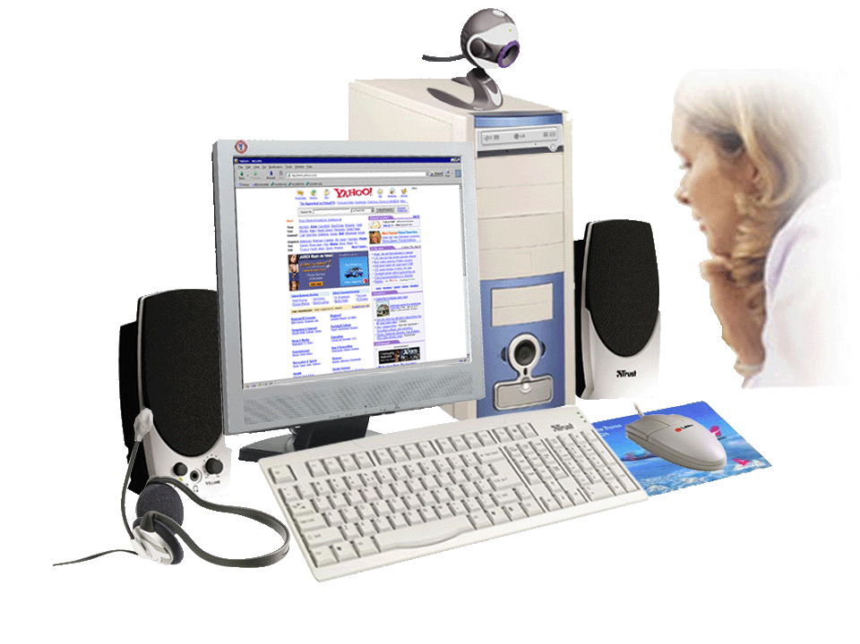 | 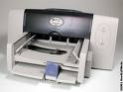
 | 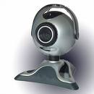
 | 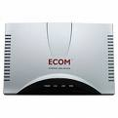
What is the type of computer like? What parts of a computer are in the pictures? What is the function of each part?

B. Parts of a computer.

A computer is an electronic machine that accepts, processes, stores and outputs information. A typical computer consists of two parts: hardware and software.
Hardware is any electronic or mechanical part of the computer system that you can see or touch.
Software is a set of instructions, called a program, which tells a computer what to do. There are three basic hardware sections.
- The CPU is the heart of the computer, a microprocessor chip which processes data and coordinates the activities of all the other units.
- The main memory holds the instructions and data which are being processed by the CPU. It has two main sections: RAM (Random Access Memory) and ROM (Read-Only Memory).
- Peripherals are the physical units attached to the computer. They include:
Input devices, which let us enter data and commands (for example, the keyboard and the mouse).
Output devices, which let us extract the results (for example, the monitor and the printer).
Storage devices, which are used to store information permanently (for example hard disks and DVD-RW drives).
Disk drives are used to read and write data on disks.
At the back of the computer there are ports into which we can plug external devices (for example, a scanner, a modem, etc.). They allow communication between the computer and the devices.

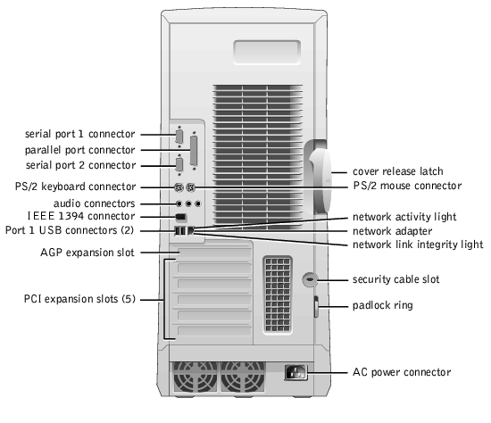

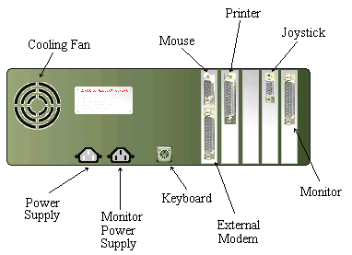

The back of a computer

C. Functions of a PC: input →processing →output→ storage

Input: We enter data with a keyboard, a webcam, etc.
Processing: The data is manipulated according to program instructions.
Storage: We keep programs and data in memory systems where they are available for processing.

Name the input, output and storage devices you can remember.

1. Complete the exercises below. Say which computer essential they refer to.
- »Accelerate your digital lifestyle by choosing a Pentium at 4.3 GHz.«
- »Right-click to display a context-sensitive menu.«
- »You will see vivid, detailed images on a 17« display.«
- »This will produce high-quality output, with sharp text and impressive graphics.«
- »Use it when you want to let the grandparents watch the new baby sleeping.«
- »Press any key to continue«.

2. Match the terms with their definitions.
1) CD/DVD drive a) any socket into which a peripheral device may be connected
2) speaker b) device used to produce voice output and play back music
3) modem c) mechanism that reads and/or writes to optical disks
4) port d) device that converts data so that is can travel over the Internet

3. Read 'The Parts of a computer' and label this diagram with the correct terms.
.

Computer system

4. Complete the diagram and sentences below with words from 'Functions of a PC'.
Functions of a computer

1. Computer _______________ is the visible or audible result of data processing – information that can be read, printed or heard by the user.
2. The CPU will process data as instructed by the programs you're running. _____________________
3. DVDs are expected to replace CDs as ______________ devices.
4. As a scanner, the Sigma 100 can be used to ______________ photographs as well as documents into the computer.
TYPES OF COMPUTER SYSTEMS

A. From mainframes to wearable computers

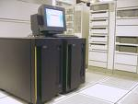 | A mainframe is the most powerful type of computer. It can process and store large amounts of data. It supports multiple users at the same time and can support more simultaneous processes than a PC. The central system is a large server connected to hundreds of terminals over a network. Mainframes are used for large-scale computing purposes in banks, big companies and universities.
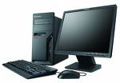 | A desktop has its own processing unit (or CPU), monitor and keyboard. It is used as a personal computer in the home or as a workstation for group work. Typical examples are the IBM PC and the Apple Macintosh. It's designed to be placed on your desk. Some models have a vertical case called a tower.
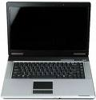 | A laptop (also called a notebook PC) is a lightweight computer that you can transport easily. It can work as fast as a desktop PC, with similar processors, memory capacity, and disk drives, but it is portable and has a smaller screen that produces very sharp images.  Instead of a mouse they have a touchpad built into the keyboard – a sensitive pad that you can touch to move the pointer on the screen.  They offer a lot of connectivity options: USB (Universal Serial Bus) ports for connecting peripherals, slots for memory cards, etc.  They come with battery packs, which let you use the computer when there are no electrical outlets available.
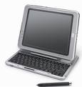 | A tablet PC looks like a book, with an LCD screen on which you can write using a special digital pen. You can fold and rotate the screen 180 degrees. Your handwriting can be recognized and converted into editable text. You can also type at the detached keyboard or use voice recognition. It's mobile and versatile.
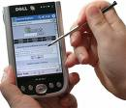 | A personal digital assistant or PDA is a tiny computer which can be held in one hand. The term PDA refers to a wide variety of hand-held devices, palmtops and pocket PCs.  For input, you type at a small keyboard or use a stylus – a special pen used with a touchscreen to select items, draw pictures, etc. Some models incorporate handwriting recognition, which enables a PDA to recognize characters written by hand. Some PDA's recognize spoken words by using voice recognition software.  They can be used as mobile phones or a personal organizers for storing notes, reminders and addresses. They also let you access the Internet via wireless technology, without cables.
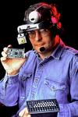 | A wearable computer runs on batteries and is worn on the user's body, for example on a belt, backpack or vest; it is designed for mobile or hands-free operation. Some devices are equipped with a wireless modem, a small keyboard and a screen; others are voice-activated and can access email or voice mail.

1. Which type of computer do these descriptions refer to?

1. a hand-held computer which can be used as a telephone, a web explorer and a personal organizer
2. a typical computer found in many businesses and popular for home users
3. a large computer used for intensive data processing and often linked to many terminals
4. a small computer that fits into items of clothing
5. a portable computer that can be closed up like a briefcase, but it can be as powerful as a desktop PC
6. a full-function PC, though it only weighs 1.2 kg – you can go to a meeting and write your notes on it, like a paper notepad; its screen mode can be changed from portrait to landscape.

2. Look at the computer advertisement and find this information.

1. What type of a computer is advertised?
2. What kind of screen does it have?
3. Which pointing device replaces the mouse?
4. What type of ports does it have for connecting cameras and music players?
5. What sort of power supply does it use?

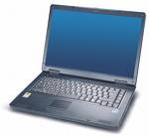 | Toshiba Satellite  - Intel Centrino Processor  - 1.024 MB RAM, 100 GB hard disk drive  - DVD SuperMulti (+/-R double layer) drive  - 15.4« widescreen TFT active matrix LCD display  - 85-key board and touchpad  - 2 memory slots, 1 PC Card or PCMCIA slot  - Wireless communications; Wi-Fi compliancy and Bluetooth  - 4 USB ports for connecting peripherals; digital camera, MP3 player, modem, etc.  - 6-cell rechargeable Lithium –ion battery pack

3. Read this interview with Adam Hawkins, an IT manager, and complete it with words from the 'PDA' section.

Interviewer: What are the basic features of a PDA?
Adam: Well, a typical PDA is a 1) ______________ device that runs on batteries and combines computing, phone and Net capabilities.
Inteviewer: And how do you enter information?
Adam: For input, you use a 2) ______________ or pen to write and make selections on a 3) _______________ ; they also have buttons for launching programs. Some models have a small keyboard. They may have a 4) _______________ system that reacts to the user's voice.
Interviewer: Do they need special software?
Adam: Yes, most of them run on Windows Mobile. Palmtops supported by Palm Inc. Palm OS. Pen-based systems include 5) _______________ , so you write on the screen and the computer recognizes your handwriting and inserts the appropriate letters.
Interviewer: What sort of things can you do with a PDA?
Adam: You can store personal information, take notes, draw diagrams and make calculations. Many PDAs can access the Net via 6) _______________ technology.

Writing.
a. Write down two benefits and two limitations of a PDA.

b. Explain shortly how laptops can be beneficial to business people.

c. Write down three examples of how tablet PCs can be used in the classroom.

