THE PROCESSOR

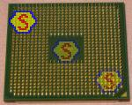

AMD processor

READ THE TEXT ABOUT THE STRUCTURE OF THE PROCESSOR AND FILL IN THE GAPS USING THE WORDS BELOW.

adaptor boards, address, registers, microprocessor, clock, conductive, buses, system board, accumulators, input or output devices

The processor consists of a _______________ 1 which is a circuit board on which are mounted _______________ 2 chips, memory chips, and other components linked together by _______________ 3 lines or channels in the form of control, address, and data _______________ 4. In addition, a processor has ________________ 5 , which are electronic circuits providing specialized functions such as graphics, or which connect a system board to _______________ 6. The system board also consists of electronic devices, such as an electronic ________________ 7 for controlling the speed of operation; ________________ 8, which store numeric data during the course of processing; and various ________________ 9, including sequence control register, _________________ 10 register and function register.

Look at the diagram below (the last page) and match the terms with the appropriate explanation.

Read the text and complete the diagram.

MATCHING.

1 microprocessor chip a used to send address details between the
memory and the address register
2 registers b consists of an arithmetic-logic unit, one or more working registers to store data being processed
3 accumulators c a group of signal lines used to transmit data in
parallel from one element of a computer to
another
4 control bus d groups of bistable devices used to store information in a computer system for high-speed access
5 address bus e an electronic circuit usually a quartz crystal, that generates electronic pulses at fixed time intervals to control the timing of all operations in the processor
6 data bus f used for storing part of the operating system and application software known as firmware; can only be read; cannot be written to or altered in any way
7 clock g used to store numeric data during processing
8 RAM h a group of signal lines dedicated to the passing of control signals
9 ROM i used for the temporary storage of application programs and data; can be written to and read from

The CPU, the heart of the computer

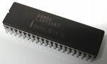

The CPU, the central processing unit, is just a tiny microprocessor chip about the size of a postage stamp, but it holds more than one million transistors and functions as the nerve centre of the entire computer.
The CPU is the part of the computer that processes data and instructions. Its key components are: a Control Unit, and Arithmetic Logic Unit, a clock and some memory registers.
The two main families of microprocessor chips are the Intel 80 x 86 and the Motorola 680 x 0.
The Intel 80 x 86 family is used in IBM PCs and compatibles. The number of transistors on 80 x 86 series microprocessors has increased exponentially since the debut of the 8086 in 1978. In 1993 the Intel Corporation introduced the Pentium processor which is 150 times faster than the speediest 8086.
The Motorola 680 x 0 family is used in the Macintosh, Atari ST and Amiga. The 68000 microprocessor was introduced in 1979 with 79,000 components. The 68040 chip with 1.2 million transistors is used in the Macintosh Quadra. Recently, the alliance of IBM, Apple, and Motorola has created the PowerPC, a microprocessor chip that runs Macintosh, Windows, OS/” and Unix software.

Now, answer the questions about the reading above.
1. What is the CPU?
2. What’s the number of transistors in it?
3. What is the function of the CPU?
4. What are the most famous families of microprocessor chips?
5. What is the best feature of the Pentium?
6. What companies joined to produce the Power PC?

OPERATING SYSTEMS - Windows 2000

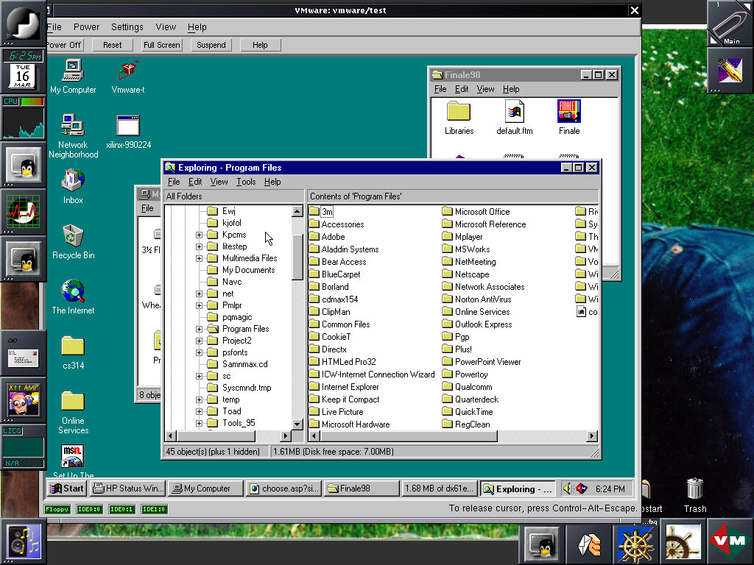

A. Read the text and match a heading to a paragraph.

Ready for the Internet
Fast, secure and reliable
What’s Windows 2000?
Built-in support for new devices
Easy to use

1 .........................................................................
Microsoft Windows® 2000 is the operating system for the next generation of PCs. It offers a user-friendly interface, NT technology, integrated web capabilities, and support for mobile computers and new devices. There are two main Windows systems: Windows 2000 Professional for desktops and laptops, and Windows 2000 Server family for networks, web servers and high-performance workstations.

2 .........................................................................
Windows 2000 includes a built-in safeguard called Windows File Protection, which prevents core system files from being deleted or changed by users or applications. If a system file is altered, this feature repairs that file avoiding many system crashing found in previous versions.
Windows 2000 is 25 percent faster than Windows 9x on systems with 64 MB and lets you run more programs and do more tasks at the same time than previous versions. It protects your hard drive by using encryption and decryption systems. It also supports Kerberos, an Internet standard which protects corporate networks or intranets.

3 .........................................................................
The graphical user interface has been improved. You can personalise the Start menu and display applications you use most often. You can use step-by-step wizards for numerous tasks. The Hardware Wizard lets users add and configure peripherals. The Network Connection Wizard helps you connect to networks. The Microsoft Installer helps you install, configure and upgrade software easily.
With IntelliMirror Technology, based on Active Directory service, desktop administrators can easily manage and back up user’s data.

4 .........................................................................
With Internet Explorer integrated into the desktop, Windows 2000 allows you to search files and folders on your PC, find pages on your company intranet or surf the web. Internet Explorer automatically corrects mistakes on common URL conventions such as http, .com and .org. It also lets you download complete web pages with graphics for viewing off-line.
NetMeeting video-conferencing software enables participants to talk to and see each other, share programs and ideas. It supports Dynamic HTML and Extensible Markup Language (XML) which help programmers create new ways of exchanging and displaying information.

5 .........................................................................

It supports the latest technologies, from digital cameras and music players to USB devices. USB (Universal Serial Bus) lets you easily connect and remove peripherals without configuring or rebooting your PC. It also offers support for storage devices such as DVD and Device Bay.
Mobile users can share files between wireless devices (laptops or desktop PCs) through the IrDA (Infrared Data Association) protocol.

B. Read the text again and find:

1. the tool that protects important system files.
2. the protocol adopted for network authentication and security.
3. the web browser included with the operating system.
4. the Internet tool used to do video-conferencing.
5. the component that allows you to add and remove hardware devices without restarting the computer.
6. A popular infrared protocol used in wireless communication.

C. Vocabulary search. Find the words in the text that correspond to the following:

Paragraph 1
1. pieces of hardware
2. portable computers

Paragraph 2
3. characteristic
4. internal corporate networks

Paragraph 3
5. set up a system in a particular way
6. improve a piece of software

Paragraph 4
7. browse (the web)
8. web address
Paragraph 5
9. restarting the computer
10. without cables

Discuss the operating systems below.

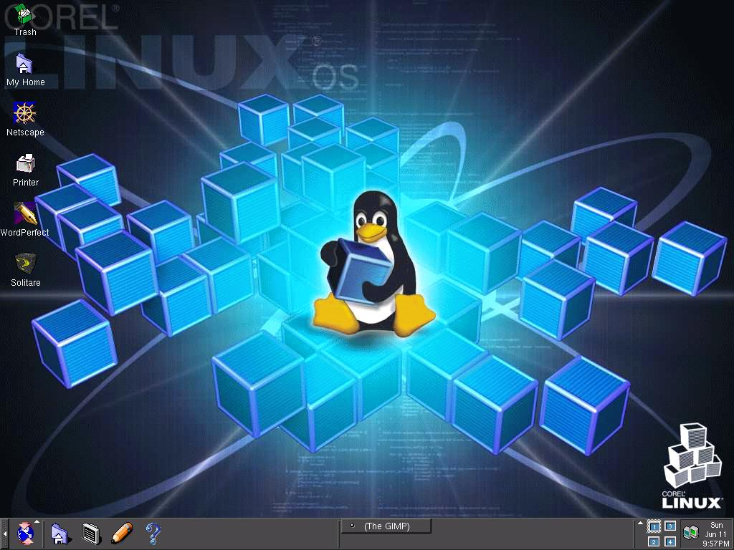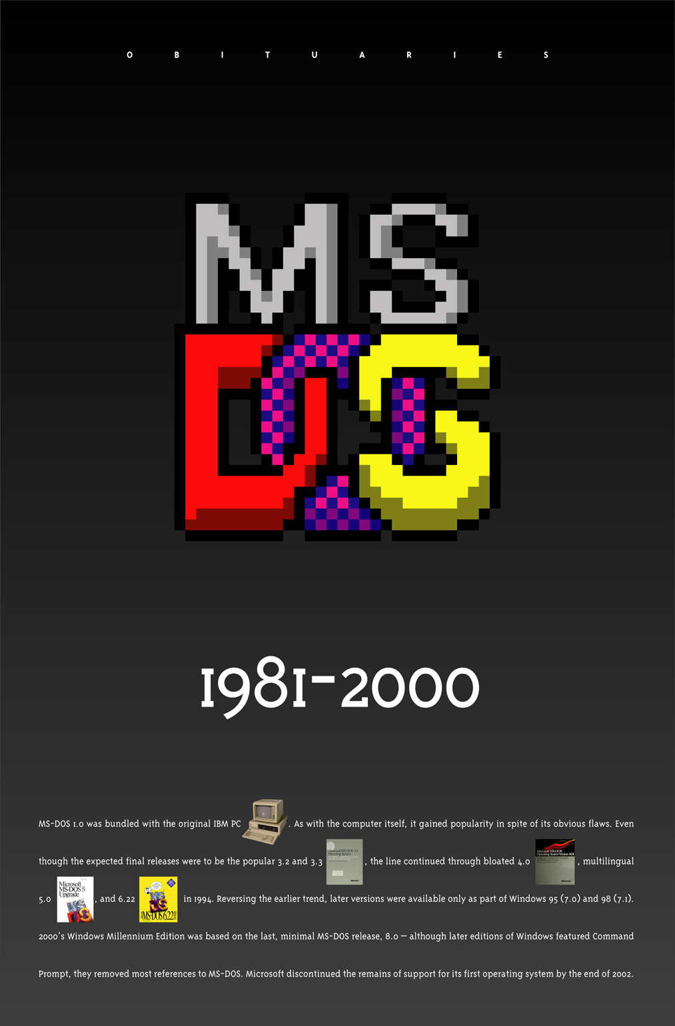

Linux MS-DOS

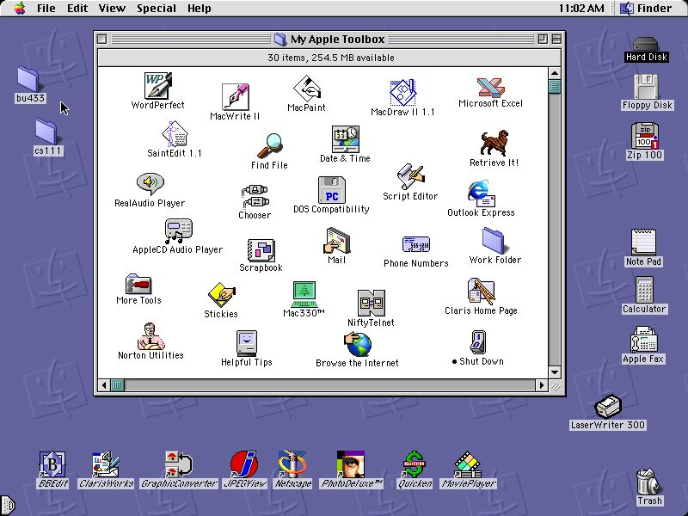

Macintosh

COMPLETE THE TEXT WITH THE PHRASES BELOW:
- ALL THE INFORMATION STORED IN THE RAM IS TEMPORARY
- MICROCOMPUTERS MAKE USE OF TWO TYPES OF MAIN MEMORY
- ROM CHIPS HAVE ‘CONSTANT’ INFORMATION
- THE SIZE OF RAM IS VERY IMPORTANT

MAIN MEMORY: RAM and ROM

The main memory of a computer is also called the 'immediate access store', as distinct from any storage memory available on the disk. _______________________________________________________________:
RAM and ROM, both contained in electronic chips connected to the main board of the computer.
RAM stands for ‘Random Access Memory’ and is the working area of the computer, that is, the basic location where the microprocessor stores the required information. It’s called ‘random access’ because the processor can find information in any cell or memory address with equal speed, instead of looking for the data in sequential order.
________________________________________________________________, so it is lost when the machine is turned off. Therefore, if we want to use this information later on, we have to save it and store it on a disk. When running an application, the microprocessor finds its location in the storage device (the floppy or hard disk) and transfers a temporary copy of the application to the RAM area. Consequently, if we want to increase the performance of a computer, when several applications are open at the same time or when a document is very complex.
The RAM capacity can sometimes be expanded by adding extra chips. These are usually contained in Single inline Memory Modules or SIMMs, which are installed in the motherboard of the computer.
We can designate a certain amount of RAM space as a cache in order to store information that an application uses repeatedly. A RAM cache may speed up our work, but it means that we need enough internal memory or a special cache card.
ROM is an acronym for ‘Read-Only Memory’ which implies that the processor can read and use the information stored in the ROM chip, but can not put information in it.
________________________________________________________________, including instructions and routines for the basic operations of the CPU. These instructions are used to start up the computer, to read the information from the keyboard, to send characters to the screen, etc. They cannot be changed and are not erased when the power is turned off. For this reason, the ROM section is also referred to as firmware.

Check the meaning of the terms in bold type.

THE SASSER WORM

The Sasser worm is the latest headache for Windows users. But what is it, how dangerous is it and what can you do about it?
What is the Sasser worm?
Sasser is a program that takes advantage of a hole in Microsoft's Windows. It is different from a virus which often travels by e-mail and relies on you clicking on an attachment.
This is a worm which means it can spread by itself, without human intervention. So you could be infected by just connecting to the internet. But the worm only affects computers running recent versions of Windows XP and Windows 2000.
Para 2 What damage does it do?
The worm causes some computers to continually crash and reboot, but it does not appear to cause any permanent damage to files or machines. Infected computers then also send out the worm, looking for more victims.
So far four variants of Sasser have been spotted on the internet. The latest version, Sasser.D, scans so aggressively for new computers to infect that it may cause networks to become congested with packets of data and slow down.
Para 3 How widespread is the Sasser worm?
Some security experts estimate that more than one million computers have been infected. Disruptions in at least seven large companies across the world have been blamed on machines infected by Sasser. Post offices have been affected in Taiwan, hospitals in Hong Kong, and banks in Australia.
Para 4 What can I do about it?
Microsoft and many security firms have released software tools that can help you find out if they are infected and to help them remove the virus from their system. A good place to start is Microsoft's own security advice page at www.microsoft.com/security/.
You should keep your Windows software up to date by regularly downloading the latest patches for free from Microsoft at windowsupdate.microsoft.com/.
Computer users are also advised to install anti-virus software and keep it up to date. If you have a broadband connection use a personal firewall to close the backdoors that some malicious programs install on your PC.
Windows XP comes with a built-in firewall but it needs to be switched on. Various firewall products are available commercially and some are free for personal use.

Find the words in the text above that mean the same.

__________para 1 describes a person, animal or activity that could harm you
__________ para 1 to use the good things in a situation
__________para 1 a kind of computer infection
__________para 1 linking
__________para 2 to harm or spoil something
__________para 2 any of several different types of container used to store papers, letters and other documents in an ordered way, especially in an office
__________para 2 to see or notice someone or something, usually because you are looking hard
__________para 2 to look at something carefully, with the eyes or with a machine, in order to obtain information
__________para 3 existing or happening in many places and/or among many people
__________para 3 a guess of what the size, value, amount, cost, etc. of something might be
__________para 3 to pass harmful programs from one computer to another, or within files in the same computer
__________para 4 companies
__________para 4 to take something or someone away from somewhere, or off something
__________para 4 modern, recent, or containing the latest information
__________para 4 to put a computer program onto a computer so that the computer can use it
__________para 4 intended to harm or upset other people
__________para 4 able to be obtained, used, or reached

More reading : Fill in the gaps.
The virus infected 1) __________18 million Windows PCs around 2) __________ world last week. The "worm" was 3) __________ from the usual viruses because it did not arrive in an e-mail attachment. It infected 4) ___________ without users doing anything. Officials searched his parents' home 5) __________ he lived, according to German newspaper reports.
The teenager's identity 6) __________ being kept a secret. But a German newspaper reported that US security agencies, the CIA and FBI, had helped 7) __________the hunt for a suspect, who called themselves "Sven J." Police said the teenager was arrested in the northern town of Rotenburg 8) __________ Friday. The worm caused computers 9) __________ keep crashing and restarting, but didn't do any permanent damage to PCs. Some big companies had to shut down until they cleared the worm from their systems. Hospitals, banks, airlines, government offices as well as home users were also affected.
It only affected Microsoft Windows machines because 10) __________ took advantage of a flaw in the Windows' software.
VIRUS: "A program or piece of code that is loaded onto your computer without your knowledge and runs against your wishes. Most viruses can also replicate themselves. All computer viruses are manmade. A simple virus that can make a copy of itself over and over again is relatively easy to produce. Even such a simple virus is dangerous because it will quickly use all available memory and bring the system to a halt. An even more dangerous type of virus is one capable of transmitting itself across networks and bypassing security systems. "
What is it? Symantec AntiVirus Research Center, Norton Anti-Virus, Dr. Solomon's, McAffee, PC-cillin, Norton Anti-Virus, Dr. Solomon's.


